The Modern Pioneers of the
Amargosa Valley

The Modern Pioneers of the
Amargosa
Valley-

Robert D. McCracken

Nye County Press
Tonopah Nevada

The Modern Pioneers of the AMARGOSA VALLEY
Robert D. McCracken

Published in 1992 by Nye County Press
PO Box 3070
Tonopah, Nevada 89049

Copyright 1992 by Nye County Press
rights reserved. No part of this publication may be
reproduced or transmitted in any form or by any means,
electronic or mechanical, including photocopy, recording, or
any information storage and retrieval system, without
permission in writing from the publisher.

Layout by Polly Christensen, Longmont, Colorado

Printed in the United States of America

Library of Congress Catalog Card Number: 90-060553
ISBN: 1-878138-58-8

for my daughter, Bambi

In appreciation for their unwavering support
and encouragement for the Nye County Town
History Project:

Nye County Commissioners
Robert "Bobby" N. Revert
Joe S. Garcia, Jr.
Richard L. Carver
Barbara J. Raper
Dave Hannigan
Joe Maslach
Cameron McRae

and Nye County Planning Consultant
Stephen T. Bradhurst, Jr.

Content
PREFACE

ACKNOWLEDGMENTS

INTRODUCTION
The Physical Setting
Amargosa Valley's Singing Sand Dune
The First Occupants

ONE EARLY EXPLORATION
The Death Valley of the Forty-niners
In the Wake of the Forty-niners

TWO EARLY SETTLERS
Cattle and Crops
The Frontier Home of Aaron and Rosie Winters
Winters Discovers Borax

THREE RAILROADS ARRIVE IN THE AMARGOSA VALLEY
Clark Builds the Las Vegas and Tonopah Railroad
Borax Smith and the Tonopah and Tidewater Railroad

FOUR THE EARLY 1900s: PEOPLE AND PLACES
"Dad" Fairbanks
A Child's Diary: Life at Ash Meadows
The Ash Meadows Clay Operations
Life in Clay Camp
Outlaw Country

FIVE THE AMARGOSA VALLEY IN THE 1930-1950s
Stops on the T&T Railroad
The T&T Ranch—The Leeland Water and Land Company
Carrara, 1912-1941

SIX MODERN DEVELOPMENT OF THE AMARGOSA VALLEY
Gordon and Billie Bettles on the T&T Ranch
Modern Pioneers: The Records Brothers
Modern Pioneer Hardships
The Struggle for Electricity
Modern Mining of Amargosa Valley Clays
The American Borate Company
Peat Mining the Carson Slough
The Spring Meadows Ranch and the Pupfish Controversy
Atomic Testing at the Nevada Test Site
Adjusting to Life in the Amargosa Valley
The Stateline—More Than a Saloon
Amargosa Becomes an Unincorporated Town

SEVEN THE FUTURE

REFERENCES

Preface

Historian generally consider the year 1890 as the close of the American frontier. By then, most of the western United States had been settled, ranches and farms developed, communities established, and roads and railroads constructed. The mining boomtowns, based on the lure of overnight riches from newly developed lodes, were but a memory.
Although Nevada was granted statehood in 1864, examination of any map of the state from the late 1800s shows that although much of the state was mapped and its geographical features named, a vast region—stretching from Belmont south to the Las Vegas meadows, comprising most of Nye County—remained largely unsettled and unmapped. In 1890 most of southcentral Nevada, including the Amargosa Valley—or the Amargosa Desert, as it was usually known—remained very much a frontier, and it continued to be so for at least another twenty years.
The great mining booms at Tonopah (1900), Goldfield (1902), and Rhyolite (1904) represent the last major flowerings of what might be called the Old West. Aside from the Canadian explorer Peter Skene Ogden, who might have set eyes on the Amargosa Valley during his 1829-1830 expedition, the first documented entry into the valley by whites was not until late 1849, when the forty-niners, who had become lost in an effort to find a shortcut to southern California, crossed the Amargosa prior to wandering into Death Valley. The first community, if it can be called that, was not founded in the Amargosa until after 1905, when Ralph Jacobus "Dad" Fairbanks established his freighting and mercantile business at the Ash Meadows spring that bears his name. The first railroad tracks did not cross the Amargosa Valley until 1906; and from the entry of the first whites until the late 1930s, the Nye County sheriff is said to have been hesitant to enter Ash Meadows because of its lawless reputation. The modern development of the Amargosa Valley by its modern pioneers did not begin until the early 1950s. Electric power, other than that produced by home generators, was not available until 1963. As a consequence, southcentral Nevada, notably Nye County perhaps more than any other region of the West—remains close to the American frontier. In a real sense, a significant part of the frontier can still be found there. It exists in the attitudes, values, lifestyles, and memories of area residents. The frontier-like character of the area also is visible in the relatively undisturbed condition of the natural environment, most of it essentially untouched by humans.
Aware of Nye County's close ties to our nation's frontier past and the scarcity of written sources on local history (especially after 1920), the Nye County Board of Commissioners initiated the Nye County Town History Project (NCTHP) in 1987. The NCTHP is an effort to systematically collect and preserve the history of Nye County. The centerpiece of the NCTHP is a large set of interviews conducted with individuals who had knowledge of local history. The interviews provide a composite view of community and county history, revealing the flow of life and events for a part of Nevada that has heretofore been largely neglected by historians. Each interview was recorded, transcribed, and then edited lightly, preserving the language and speech patterns of those interviewed. All oral history interviews have been printed on acid-free paper and bound and archived in Nye County libraries, Special Collections in the James R. Dickinson Library at the University of Nevada, Las Vegas, and at other archival sites located throughout Nevada.
Collection of the oral histories has been accompanied by the assembling of a set of photographs depicting each community's history. These pictures have been obtained from participants in the oral history interviews and other present and past Nye County residents. Complete sets of these photographs have been archived along with the oral histories.
The oral histories and photo collections, as well as written sources, served as the basis for the preparation of this volume on the history of Amargosa Valley. It is one of a series on the history of all major Nye County communities.
In a real sense this volume, like the others in the NCTHP series, is the result of a community effort. Before the oral interviews were conducted, a number of local residents provided advice on which community members had lived in the area the longest, possessed and recalled information not available to others, and were available and willing to participate. Because of time and budgetary constraints, many highly qualified persons were not interviewed.
Following the interviews, the participants gave even more of their time and energy: They elaborated upon and clarified points made during the taped interviews; they went through family albums and identified photographs; and they located books, dates, family records, and so forth. During the preparation of this manuscript, a number of community members were contacted, sometimes repeatedly (if asked, some would probably readily admit that they felt pestered), to answer questions that arose during the writing and editing of the manuscript. Moreover, once the manuscripts were in more or less final form, each individual who was discussed for more than a paragraph or two in the text was provided with a copy of his or her portion of the text and was asked to check that portion for errors. Appropriate changes were then made in the manuscript.
Once that stage was completed, several individuals in the Amargosa Valley area were asked to review the entire manuscript for errors of omission and commission. At each stage, this quality-control process resulted in the elimination of factual errors and raised our confidence in the validity of the contents.
The author's training as an anthropologist, not a historian (although the difference between the disciplines is probably less than some might suppose), likely has something to do with the community approach taken in the preparation of this volume. It also may contribute to the focus on the details of individuals and their families as opposed to a general description of local residents and their communities. Perhaps this volume, as well as a concern with variability among individuals and their contribution to a community, reflects an "ethnographic," as opposed to a "historical," perspective on local history. In the author's view, there is no such thing as "the history" of a community; there are many histories of a community. A community's history is like a sunrise—the colors are determined by a multitude of factors, such as the time of year, weather, and point of view. This history of Amargosa Valley was greatly determined by the input of those who helped produce it. If others had participated, both the subjects treated and the relative emphasis the subjects received would have been, at least, somewhat different. Many basic facts would, of course, remain much the same—such things as names, dates, and locations of events. But the focus, the details illustrating how facts and human beings come together, would have been different. History is, and always will remain, sensitive to perspective and impressionistic, in the finest and most beautiful sense of the word.
A longer and more thoroughly referenced (though non-illustrated) companion to this volume, titled A History of Amargosa Valley, Nevada, is also available through Nye County Press. Virtually all the written material contained in this volume was obtained from the longer volume. Those who desire more comprehensive referencing should consult the longer version of Amargosa Valley history.
I hope that readers enjoy this history of Amargosa Valley. True to their heritage, Amargosa's residents possess the frontier's warmth and friendliness, free of pretention. They reside in an incomparably beautiful valley that presents magnificent vistas of desert, mountains, and sky and offers a rare sense of peace and solitude. The natural world and the people in it are properly conjoined in the Amargosa Valley.
Robert D. McCracken

Acknowledgments

This volume was produced under the Nye County Town History Project, initiated by the Nye County Board of Commissioners. Appreciation goes to Chairman Joe S. Garcia, Jr., Robert "Bobby" N. Revert, and Pat Mankins; Mr. Revert and Mr. Garcia, in particular, showed deep interest and unyielding support for the project from its inception. Thanks also go to current commissioners Richard L. Carver and Barbara J. Raper, who joined Mr. Revert on the board and who continued the project with enthusiastic support. Commissioners Dave Hannigan, Joe Maslach, and Cameron McRae—all elected in 1990—have provided on-going commitment. Stephen T. Bradhurst, Jr., planning consultant for Nye County, gave unwavering support and advocacy, provided advice and input regarding the conduct of the research, and constantly served as a sounding board as production problems were worked out. This volume would never have been possible without the enthusiastic support of the Nye County commissioners and Mr. Bradhurst.
Thanks go to the participants of the Nye County Town History Project, especially those from Amargosa Valley and the Amargosa area, who kindly provided much of the information; thanks, also, to residents from Amargosa Valley and throughout southern Nevada — too numerous to mention by name — who provided assistance, historical information, and photographs, many of which are included in this volume.
Jean Charney and Jean Stoess did the word processing and, along with Gary Roberts, Maire Hayes, and Jodie Hanson, provided editorial comments, review, and suggestions. Alice Levine and Michelle Starika edited several drafts of the manuscript and contributed measurably to this volume's scholarship and readability; Alice Levine also served as production consultant. Polly Christensen was responsible for re-design and layout. Gretchen Loeffler and Bambi McCracken assisted in numerous secretarial and clerical duties. Doris Jackson, Hank Records, Betty-Jo Boyd, Deke Lowe, and Celesta Lowe kindly critiqued several drafts of the manuscript; their assistance and support have been invaluable. Kevin Rafferty and Lynda Blair, from the University of Nevada, Las Vegas, Environmental Research Center, provided helpful suggestions on the section concerning the archaeology of Native Americans in the Amargosa Valley area. Phillip Earl of the Nevada Historical Society contributed valuable support and criticism throughout, and Tom King at the Oral History Program of the University of Nevada, Reno, served as consulting oral historian. Susan Jarvis and Kathy War of Special Collections, James R. Dickinson Library, University of Nevada, Las Vegas, assisted greatly with research conducted at that institution. Much deserved thanks are extended to all these persons.
All aspects of production of this volume were supported by the U.S. Department of Energy, Grant No. DE-FG08-89NV10820. However, any opinions, findings, conclusions, or recommendations expressed herein are those of the author and do not necessarily reflect the views of DOE. Any errors and deficiencies are, of course, the author's responsibility.
R. D. M.

The Modern Pioneers of the
Amargosa Valley

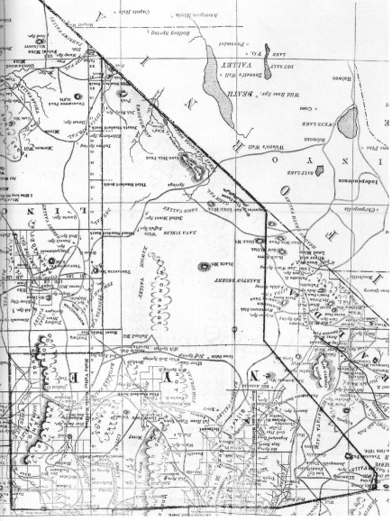
Map of Nye County, Nevada, 1881. Note that the northern part of the county is crossed by many roads while south of Stone Cabin, the area—particularly Amargosa and Ash Meadows—has scarcely been settled. Native Americans, of course, had resided in the area for thousands of years. - Nye County Town History Project—Ed Slavin

Introduction

The Amargosa Valley did not yield itself easily to human habitation. Although it is not as famous (or notorious) as Death Valley, its immediate neighbor to the west, the Amargosa is formidable enough. Rainfall is scarce, and vegetation is sparse; most of the valley is arid and treeless. This volume describes some of the efforts of the hearty individuals who have succeeded in making the valley their home.

The Physical Setting

The Amargosa Valley is a broad, flat valley lying mostly south, but in some locations a little north, of U.S. Highway 95 between Beatty and a point a few miles west of Mercury in southern Nye County, Nevada. It is approximately 12 miles wide and between 2100 to 3000 feet above sea level.
The term Amargosa comes from the Spanish word amargroso, which means "bitter" and refers to the quality of the water in the Amargosa River. The Amargosa River begins 10 miles north of Beatty at Springdale, taking its water from springs, and flows beneath the surface southeastward across the Amargosa Valley "to the California line, where it turns northwest and becomes lost in Death Valley" (Carlson, 1974:36). The Amargosa has been variously known as Alkali Creek, The Bitter Water, Bitter Water Creek, Salaratus Creek, Amargoshe Creek, and Anorgosa.
Though the valley as a whole is sparsely vegetated, Ash Meadows is an exception. It is a verdant area in the southeast portion of the valley featuring meadows and springs, so named for the leather-leafed ash trees that grow in abundance there. Ash Meadows, which is approximately 63 square miles, has elevation ranges between 2120 and 2800 feet above sea level. More than 20 major springs discharge an average of 17,000 acre-feet of mineral-rich water annually, creating a "natural desert oasis unsurpassed by any in the American Southwest" (Cook and Williams, 1982:1-1). Water from these springs is said to originate in the deep, carboniferous aquifer that underlies much of eastern and southern Nevada and western Utah. In the Amargosa Valley farm area, by contrast, the wells draw water that is of surface origin, draining the large area to the northeast of the Amargosa Valley.

Amargosa Valley's Singing Sand Dune

For centuries people in the Middle East and in China have noted that some desert sand dunes emit acoustical energy (sound) when disturbed. The phenomenon has been described variously as roaring, booming, squeaking, singing, or resembling one of several musical instruments (kettle drum, zither, tambourine, bass violin, or trumpet). Other descriptions liken the sound to a foghorn or a low-flying, propeller-driven aircraft (Trexler and Melhorn, 1986:147).
Most desert dunes do not emit sound: only about thirty around the world are known to do so. And those that do, do not sing on all occasions. Dune sound emissions are not well understood, but they appear to be connected to the "mechanical coupling between grains" when sands avalanche down a dune slope. The initial sound, which is produced by the grains abrading on each other, becomes a lower audio frequency that is then amplified. In some instances an observer can feel the vibrations when a dune sings (Trexler and Melhorn, 1986:148).
Three singing dunes are known in Nevada: one at Sand Mountain 18 miles southeast of Fallon; Crescent Dunes about 10 miles northeast of Tonopah; and Big Dune in the Amargosa Valley.
Big Dune lies in the northern part of the Amargosa Valley, about 10 miles south of Beatty and 5.5 miles northeast of the Nevada-California state line. It is clearly visible in the distance to the southwest from U.S. Highway 95. Big Dune's crest is approximately 300 feet above the valley floor. It is reached by turning south off Highway 95 at the Amargosa Farm sign, proceeding 2.5 miles, then west on the dirt road in the direction of the dune. In 1985 the photogenic beauty of Big Dune provided the backdrop for scenes in which Las Vegas Strip casinos were buried in desert sands in the futuristic movie Cherry 2000.

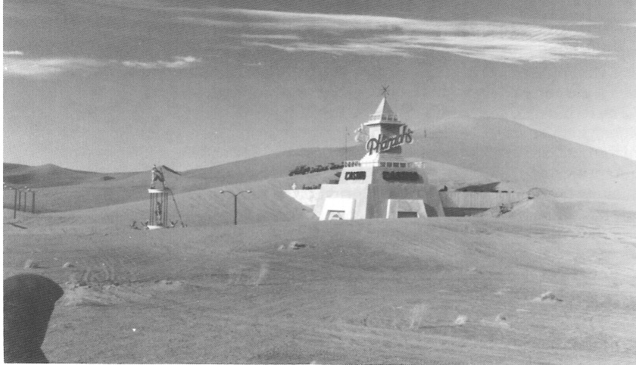
In 1985, Amargosa Valley's singing sand dune was the backdrop for the movie Cherry 2000 in which Las Vegas casinos were buried in the sand -Nye County Town History Project - McCracken Collection

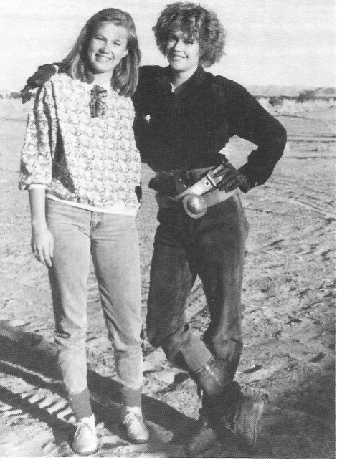
Actress Melanie Griffith (right) and her stand-in, Bambi McCracken, on location in the Amargosa Valley during the filming of Cherry 2000 in 1985. - Nye County Town History Project - McCracken Collection

The First Occupants

We do not know when humans first entered the Amargosa Valley. Ancient campsites testify to the occupation of Death Valley by human beings at least 10,000 years ago, after the end of the last Ice Age. Recent examination of archaeological remains in the Amargosa Valley implies more extensive use by aborigines than had been previously estimated. Remains show interesting relationships to adjoining areas and peoples, with possible long-term occupation. Pottery remains dating from around A.D. 1000 to historic times have been found. They indicate seasonal use of the Amargosa Valley by semisedentary hunters and gatherers, as well as more nomadic groups. Pottery remains from the Virgin Anasazi dating from A.D. 500 to A.D. 1200 have also been found at sites in Ash Meadows.
During the nineteenth century, two groups of American Indians occupied the Amargosa Valley: the Southern Paiute and the Western Shoshone. Both groups subsisted on wild plant foods supplemented by game, and both were extremely adept at extracting a living from a marginal environment.
The greatest asset of the Southern Paiute living in the Amargosa Valley was the Spring Mountains to the east, which rise to a height of 11,912 feet at Charleston Peak. The mountains afforded abundant pine nut seeds and considerable game. Mesquite grew in abundance at Ash Meadows, and beans were picked in family-owned groves; screw beans were another important food source, though not as abundant as mesquite in Ash Meadows. Paiute also picked sand bunch grass seeds at the Calico Hills and at the Big Dune.
The Ash Meadows Paiute, like their neighbors in Pahrump Valley, also practiced horticulture. They grew corn, squash, beans, and sunflowers in small fields in moist soil near streams. Families without land traded wild plants and foods for cultivated crops.
Hunting played a relatively minor role in Southern Paiute survival. The Ash Meadows Paiute hunted deer in the Spring Mountains, where they dried the meat and skins and carried their take home in nets. Mountain sheep, which were abundant at that time, could be found in the Funeral Mountains and in the mountains between the Amargosa River and Pahrump Valley. Deer and sheep were hunted both by individuals and by groups of men without leaders or formal organization. It was customary, even obligatory, for the hunter to share game with his neighbors (Steward, 1970:182-184).
The only outstanding group activity that united the Southern Paiute residing in the area was the annual fall festival. Members of several small groups or encampments attended. Visitors would come from Beatty, Ash Meadows, Pahrump Valley, Las Vegas, and even from San Bernardino. The festival was planned months in advance and was directed by the local chief. Chiefs had little authority outside their own small groups, which were composed of extended family members. The chief made speeches and the people danced, often at the same time. The festival lasted three or four days and on the last night, buckskins and other items were burned in honor of those who had died within the year. The last such festival was held shortly after the turn of the century.
The Western Shoshone occupied the area north and west of the Amargosa Valley. The variety of terrain roamed by the Shoshone is probably greater than any other area of equal size in North America, ranging from Death Valley to elevations high in the Panamint Mountains and Sierra Nevada. A family usually wintered in the same area year after year (Steward, 1970:72).
Most of the year, Shoshone Indian families pursued subsistence independently. Their main food sources were vegetable, with the most important being pine nuts. In good years, enough pine nuts could be gathered in a few weeks, or at most two months, to last most of the winter. In the spring, when food supplies became exhausted, families would usually leave their winter villages to seek out the first greens of spring and to hunt antelope and rabbits. During the summer, small groups would move into areas where different seeds ripened at different times. Journeys into the mountains also afforded the opportunity to escape the summer heat of the valleys.
Like the Southern Paiute, the Shoshone held a fall festival, also led by the local chief, which included the circle dance, gambling, and the annual mourning observances. The festival attracted people from considerable territory and they participated with great enthusiasm.

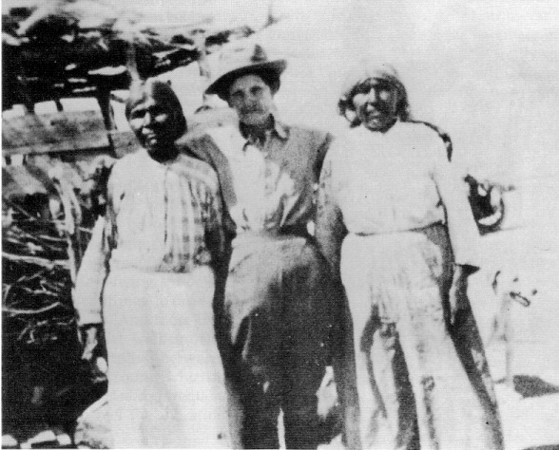
Unidentified white woman (perhaps a Manse family member from Pahrump) with two Ash Meadows Indian women, circa 1900. San Bernardino County Museum—Fisk Collection

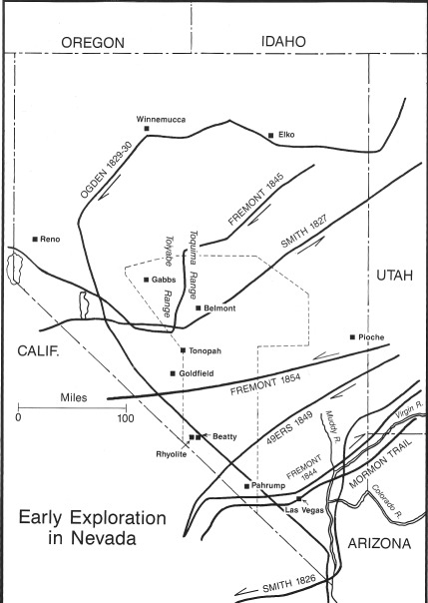
Map showing early exploration in central Nevada. H. Gary Raham

CHAPTER ONE
Early Exploration

The vast region of southcentral Nevada remained relatively unexplored until the 1850s. Jedediah Smith, an American fur trapper, was the first to explore the Colorado River on Nevada's southern border; he made forays into that country in 1826 and again in 1827. New Mexican merchant Antonio Armijo is credited with pioneering the cutoff from the Colorado River that led through the Las Vegas Valley and across the Pahrump Valley in 1829. This route, which became a portion of the Old Spanish Trail, enjoyed extensive use between 1830 and about 1848. After 1848 the route from Los Angeles to Santa Fe fell into disuse and the Las Vegas portion became part of what was known as the Mormon Trail, joining Salt Lake City with southern California.
It is possible, though not likely, that Canadian trapper and explorer Peter Skene Ogden passed through the Amargosa Valley as he traveled south through southcentral Nevada in his Snake Country Expedition of 1829-1830.
In the spring of 1844, John C. Fremont, on his second expedition, passed through the Pahrump Valley and the Las Vegas Meadows on his way east. Fremont published a map of the Great Basin in Jedediah Smith, early explorer and fur 1848, which featured a substantial— though, as we now know, nonexistent—mountain range running east and west across the Great Basin in the vicinity of present-day Beatty. Fremont based his map on information gathered on his third expedition in 1845-1846, when his party passed north of Tonopah in the Toiyabe Range area.

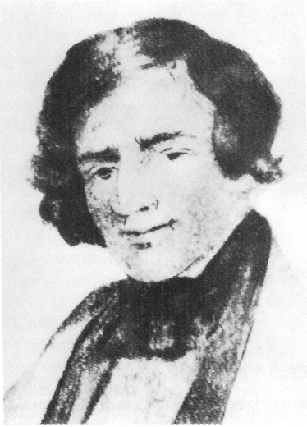
Jedediah Smith, early explorer and fur trapper - University of Nevada, Las Vegas - Dickinson Library Special Collections

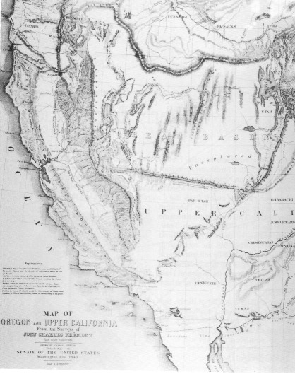
Portion of John C. Fremont's map (1848) of the Great Basin, showing a nonexistent mountain range running east and west at about the latitude of present-day Beatty, Nevada.
University of Nevada, Las Vegas—Dickinson Library Special Collections

The Death Valley of the Forty-Niners

The saga of the forty-niners' troubles in Death Valley is one of the best-known, dramatic, and heroic tales in the history of the American West. It begins with the discovery of gold in California at Sutter's Mill on the American River on January 24, 1848. Prior to 1849, approximately 15,000 people had migrated to California and Oregon by the transcontinental route. Another 4600, mostly Mormons, had settled in the Salt Lake Valley. In contrast, an estimated 25,000 people migrated overland to California in 1849, the first year of the Gold Rush.
During the late summer and fall of 1849 a large number of California-bound travelers arrived in Salt Lake City. They were well aware of the dangers of crossing the Sierra Nevada late in the season and were encouraged by the Mormons to travel south from Salt Lake City to a point where they could join the Old Spanish Trail, which would in turn lead them safely to Los Angeles. They were advised that they could then travel north through California to the gold fields. The advantages of the southern route were a minimum of snow and no major mountain ranges to cross.
The travelers accepted the Mormons' advice and hired as a guide Jefferson Hunt, a former captain of the Mormon Battalion in the Mexican War. Hunt had traversed the trail in the winter of 1847-1848. He charged a fee of $10 per wagon. In early October 1849 Hunt led a wagon train, consisting of more than 100 wagons and roughly 1000 oxen, cattle, and pack animals, south from Hobble Creek, south of Provo, Utah.
After the wagons had been on the trail for about two weeks, they were overtaken by a party of packers led by a 20-year-old New Yorker, Captain Orson K. Smith. Smith was in possession of a map, which, it was said, would cut 300 to 500 miles off the trip to the California gold fields. The map is believed to have been a print of Fremont's 1848 map of the Great Basin, with some additions made by a mountain man named Williams and information supplied by the "celebrated chief of the Ute horsethieves, Walkara" (Belden, 1956:22). Dissention arose among the travelers: stay with Jefferson Hunt as agreed or follow Captain Smith with his map. They were in a hurry to reach California, so the majority elected to go with Smith. As they left, Jefferson Hunt warned them, "If you want to follow Captain Smith, I can't help it, but I believe you will get into the jaws of Hell" (Lingenfelter, 1986:39).
Those travelers who elected to stay with Hunt or eventually returned to his route arrived safely in due time in southern California. Those who chose to go with Smith and stayed with him did, indeed, go "into the jaws of Hell." Traveling only with pack animals, Smith quickly left his followers and their wagons behind. Those who continued soon broke into small groups seeking different routes across the unknown wastes of Nevada. One such group was the Jayhawkers, approximately 3 dozen men, mostly from Knoxville and Galesburg, Illinois, with a dozen wagons between them. Another was the Bugsmashers, approximately a dozen men, including 3 blacks, mostly from Georgia and Mississippi, with about a half-dozen wagons. There were a number of families, including those of Asabell Bennett, John Arcan, Harry Wade, and the Reverend James Brier. William L. Manly and John H. Rogers, who later proved to be heroes of the misadventure, were with the Bennett-Arcan families. In all, over 80 men, 4 women, 11 children, more than 2 dozen wagons, and over 100 oxen continued on the so-called shortcut.
The travelers who stayed with Hunt followed a course that roughly parallels Interstate Highway 15. Those who were led astray by Smith's 1848 Fremont map headed due west from Enterprise, Utah. After three days of easy travel up Shoal Creek, those who had split off from Hunt encountered Beaver Dam Wash and a long, deep precipice (which became known as Mount Misery) that stopped the oxen. With his pack animals, Smith was able to find a way around, but the others were not. About 75 wagons turned back at Mount Misery to follow Hunt. Those who stayed found a detour and continued west, breaking into even-smaller groups. Near Papoose Dry Lake, in southwestern Nevada, the Bugsmashers, the Jayhawkers, and the Brier family headed due west, while another group of at least 7 wagons, the Bennett-Arcan group, turned south. All parties eventually wound up in the Amargosa Valley on their way to Death Valley, thus becoming the first non-Indians known to have set foot in the valley (Johnson, 1987:4).
The Jayhawkers, the Georgia-Mississippi Bugsmashers, and the Briers entered the Amargosa Valley in the vicinity of Fortymile Canyon, "a wash and a canyon extending northward from a point west of Lathrop Wells and southeast of Yucca Mountain" (Carlson, 1974:115). The Briers and another man were forced to abandon their wagons in the vicinity of Fortymile Canyon; they hiked out of its mouth and the "mountains ahead forced them south along the Amargosa riverbed until they found a path heading west—near Death Valley Junction" (Johnson, 1987:172). The Briers, the Georgian Bugsmashers, and the Jayhawkers used Furnace Creek Wash as a gateway into Death Valley, while the Mississippian Bugsmashers used a more northerly route, possibly Cox Creek. The Georgians abandoned their wagons in the Amargosa Valley at a place now known as Lost Wagons.
Much of the trouble later encountered by the Bennett-Arcan parties in Death Valley could have been avoided. William L. Manly, scouting ahead, climbed Mount Sterling at the northwest end of the Spring Mountains and saw smoke from campfires 30 miles to the south. Historian Richard E. Lingenfelter suggested the smoke must have been from the camps of the last straggling wagons of the Hunt train, which had turned back to the Spanish/Mormon Trail and were camped at either Stump Spring or Resting Spring at the time.

Ironically, Manly didn't realize that after more than a month of wandering he was only two days' travel from the Spanish Trail and that relief was in sight. Instead, he concluded that the smoke was from Indian camps, so he decided that he and the families should also head west. Thus they followed the Jayhawkers and Bugsmashers into Death Valley, but at the mouth of Furnace Creek they turned south again, away from the others and into the very sink of Death Valley, to camp at the springs west of Badwater. There, on the verge of starvation, the Bennett and Arcan families would remain for over a month (Lingenfelter, 1986:42-43).

All but one of the parties that had wandered into Death Valley found various routes out of their predicament. One Jayhawker party escaped the valley by ascending Towne Pass. One forty-niner, Harry Wade, found a path through Wingate Wash, pioneering the trail used by the first borax wagons from Death Valley to Daggett. No one realized that escape from Death Valley was possible simply by following the valley farther south instead of trying to cross the mountains to the west (Lingenfelter, 1986:51).
The Bennett and Arcan parties eventually had to be rescued from Death Valley when Manly and Rogers walked out of Death Valley into the San Fernando Valley to save their companions. The story of that rescue is one of the great examples of courage in the American West. The men walked across 270 miles of unmapped desert and mountains from Death Valley into the San Fernando Valley, then returned with supplies to assist their companions. They could have easily abandoned the families, as four wagon drivers had done earlier.
On the morning of February 15, Manly, Rogers, and the Bennett and Arcan families were camped high in the Panamints just short of the crest. They had climbed a little knoll beyond the pass so that they might study the route of their journey to come. On the way down, Arcan took a long look back at the valley from which he had emerged and uttered his famous farewell: "Good-bye Death Valley!" And so the valley was named (Lingenfelter, 1986:50-51).

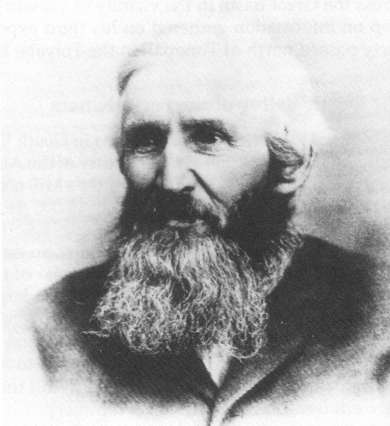
William L. Manly was one of the forty-niners who nearly perished in Death Valley. The rescue of the Bennett-Arcan parties from Death Valley by Manly and his companion, John H. Rogers, stands as one of the great acts of heroism in the frontier West. This photo was taken many years after the rescue. - University of Nevada, Las Vegas—Dickinson Library Special Collections

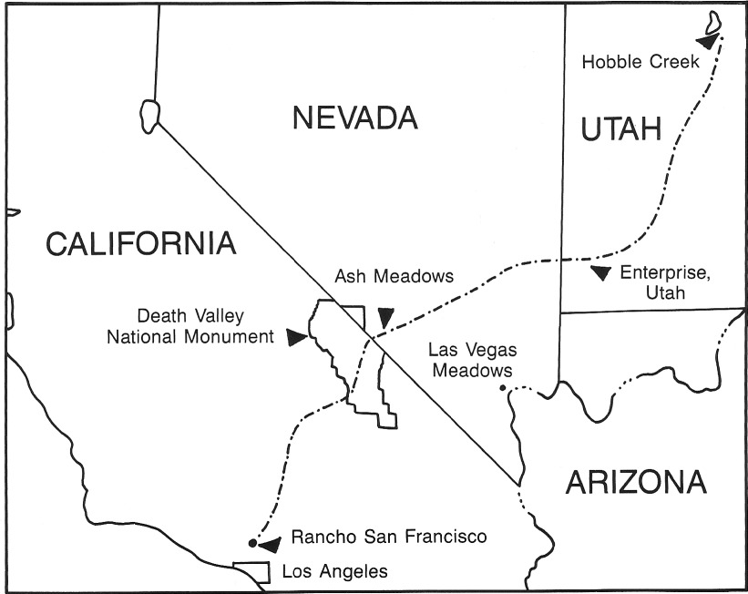
Approximate route taken by the Bennett-Arcan party from Hobble Creek, Utah, to Rancho San Francisco (near Los Angeles). The group passed through the Amargosa Valley and Ash Meadows during the winter of 1849-1850. - Map by R. Gary Raham (after Johnson 1987)

In the Wake of the Forty-Niners

The argonauts' narrow escape from Death Valley became widely known and fueled interest in the region. Tales of lost silver and gold mines added to the fire. Such tales drew numerous prospectors to the area.
Jim Martin, one of the Bugsmashers from the Georgia and Mississippi party, had found rich silver-lead ore in a spur of the Panamints while escaping, and later he had a specimen that he had carried out refined and made into a gunsight. As early as the 1850s his find became known as the Lost Gunsight Lode.
Charles C. Breyfogle had come west in 1849, spent time in California and the Comstock, and was running a hotel at Geneva on the east slope of the Toiyabe Range in 1863. The lost gold mine that bears his name fired the imagination of untold numbers of gold seekers in the Amargosa Valley area for decades. Accounts of Breyfogle's discovery vary. One version holds that years before, he had met one of the Death Valley forty-niners, who told of a vast ledge of quartz rich in gold. In 1864 Breyfogle and some companions set out to find the gold. Upon arriving at the Amargosa Valley they split up to prospect the surrounding hills, and Breyfogle finally returned to camp half-starved after having been lost. He had several specimens that later were said to have assayed as high as $4500 a ton in gold. As luck would have it, the party was out of food and had to leave. Although he returned to the area several times, Breyfogle was never able to locate the place where he originally found his rich specimen. During one trip there, in 1865, he was attacked and nearly killed by Ash Meadow Paiute as he wandered along the Amargosa River. The deposit of gold became known as the Lost Breyfogle Lode. Those looking for it were said to have gone "Breyfogling." No one knows how many manhours and how much money were later spent looking for the Lost Gunsight and Breyfogle lodes, but they were very substantial (Lingenfelter, 1986:59, 73-79).
By the late 1860s, small mining operations had started at the north end of Death Valley, and by the early 1870s small mining operations were in full swing in the Panamint Range. Governmental and privately sponsored surveyors arrived in the Amargosa Valley region not far behind the first miners. Lt. George M. Wheeler's scientific and topographic surveys for the U.S. Army Corps of Engineers in 1871 are among the most well known. A contingent of the 1871 survey, under direction of Second Lieutenant D. A. Lyle, camped in Ash Meadows during the summer of 1871.

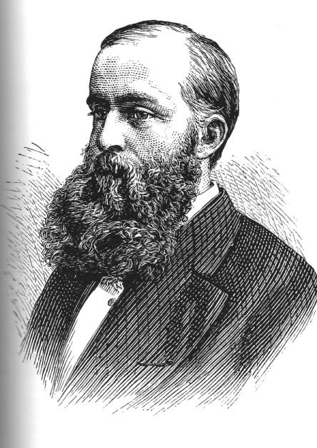
GEORGE M. WHEELER.
Lt. George M. Wheeler directed several scientific and topographic surveys of the Amargosa—Death Valley region for the U.S. Army Corps of Engineers in 1871. - U.S. Library of Congress

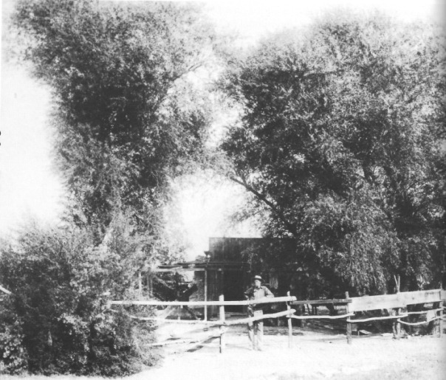
Philander (Phi) Lee in front of his home at Resting Spring, about 5 miles east of Tecopa, California (circa 1890). His brother, Leander (Cub) Lee, built the first house in the Southern Paiute camp, which later became Shoshone. Nye County Town History Project—Lowe Collection

CHAPTER TWO
Early Settlers

The mining boom in the Death Valley area in the 1870s attracted settlers. The first white man to settle in the Amargosa Valley was Charles King. King was a Yankee who had gone to California with the Gold Rush in 1850. He was working as a miner in Timpahute in Lincoln County in the summer of 1871 when Wheeler's survey came through, and he signed on as a guide. King used his position with Wheeler to examine business prospects in the areas through which he traveled. With mining operations already established at Ivanpah and Chloride Cliff, and others opening in the nearby hills, King recognized that rangeland in Ash Meadows would be valuable. With its perennial springs and seeps, Ash Meadows contained thousands of acres of virgin grasslands. All he need do was claim it.

Cattle and Crops

With backing from Pioche mining superintendent Charles Forman, King purchased a herd of 1300 head of cattle in southern California and drove them to Ash Meadows in January 1873, where the cattle had free range. King purchased his cattle for a few cents a pound on the hoof in California, fattened them up at his Ash Meadows ranch, and sold them to miners in the vicinity for more than 30 cents a pound, slaughtered. Though alkali, black leg, and Paiute arrows took their toll on King's cattle, his operation was successful. King's beef was worth more per ton than the ore being mined in the Panamint Range. King constructed a stone house at what is now the Point of Rocks Spring.
In the winter of 1874-1875, the Lee brothers, Philander and Leander (known as Phi and Cub), both in their early twenties, staked out a spring near King. They had brought with them a herd of cattle from the San Joaquin Valley. Like some other early settlers in the area, they married Paiute women.
In the fall of 1879, Eugene Lander started a ranch near the present town of Beatty. By the end of the 1870s, most of the springs and seeps along the Amargosa River from Beatty south and in the Pahrump Valley had been taken up by homesteaders. By the early 1880s, the decline of Ivanpah and Tecopa mines had deprived ranchers and farmers of markets, and most had been forced to abandon their homesteads.
Andrew Jackson Longstreet, another early settler in Ash Meadows, is now a near legend in southern Nevada. Longstreet was a southerner, but little is known of the first 40 years of his life. He was said to have had five notches on his gun and was described as "the most perfect typification of the Old West's gunman" (Lingenfelter, 1986:168). He wore his hair long to cover his ears, which had been cropped for rustling when he was a youth. In the early 1880s, he ran a store and saloon in the Muddy River area east of present-day Las Vegas. Later he left Moapa and homesteaded in Oasis Valley, and by 1889 he had homesteaded at Ash Meadows. Longstreet, who spoke Paiute, was married to an Ash Meadows Paiute woman named Fannie Black. He was active in Nevada as an advocate for Indian rights on many occasions. At Ash Meadows he lived in a cabin that stood near the spring that bears his name; the cabin was destroyed by flood waters in 1984. Longstreet knew the Death Valley country well and possessed many desert survival skills. Though he kept the Ash Meadows ranch until1906, in 1899 he moved farther north in Nye County to the Hawes Canyon Ranch, located on the west side of the Kawich Mountains. He died in 1928 and is buried in the cemetery at Belmont, Nevada (Zanjani, 1988).
Most of the homesteads in the Amargosa area during this period were 160-acre claims. The homesteaders were generally unable to irrigate more than a fraction of the claim, however. During the mining booms, most of the homesteads were hay ranches, since alfalfa was a profitable crop. Farmers could get four cuttings a year and the yield was about 6 tons to the acre. Hay was worth anywhere from $70 to $200 a ton in the mining camps, depending on the market. Farmers also raised barley, for which they could obtain $200 a ton, but the yield was only about 2 tons per acre. They also raised vegetables, including corn, beans, potatoes, beets, cabbages, onions, squash, and melons, for which they also could receive $200 a ton. For those who planted trees, such as apples, peaches, pears, figs, plums, apricots, nectarines, almonds, and walnuts, the payoff was over $500 a ton. A few ranchers raised grapes and made wine. Nearly all ranchers kept stock but, unlike King, none had more than 100 head. Houses ranged from brush and mud jacals to adobe and stone structures. Some had wooden floors with cellars and cool verandas (Lingenfelter, 1986:169).

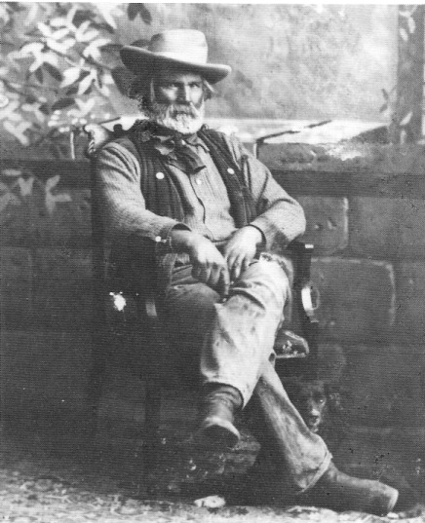
Jack Longstreet (circa 1905), a legendary desert frontiersman, was an early settler in Ash Meadows. - Central Nevada Historical Society—Fuson Collection

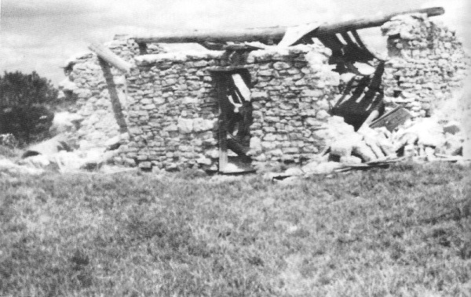
Remains of Jack Longstreet's home at the spring that bears his name in Ash Meadows, Nevada, a year prior to its destruction by a flash flood in 1984. - Nye County Town History Project—Ford Collection

The Frontier Home of Aaron and Rosie Winters

Aaron and Rosie Winters were among the best-known early residents of the Amargosa Valley. They lived in a stone house at Ash Meadows in "abject poverty" at the time of the following description. The Winters apparently were in the area by the end of the 1870s. The house they lived in probably originally belonged to Charles King, and it is said to have been a typical residence of the area. The following account of the Winters' home was by C. M. Plumb, who visited at the time; it appeared in John R. Spears' classic volume, Illustrated Sketches of Death Valley.

Close against the hill, one side half-hewn out of the rock, stood a low stone building, with a tule-thatched roof. The single room within was about fifteen feet square. In front was a canvas-covered addition of about the same size. The earth, somewhat cleared of broken rock originally there, served as a floor for both rooms. There was a door to the stone structure, and directly opposite this was a fire-place, while a cook-stove stood on a projecting rock at one side of it. At the right was a bed, and at the foot of the bed a few shelves for dishes. A cotton curtain was stretched over some clothing hanging on wooden pegs in the corner.
On the other side was the lady's boudoir—a curiosity in its way. There was a window with a deep ledge there. A newspaper with a towel covered the ledge, in the center of which was a starch box supporting a small looking-glass. On each side of the mirror hung old brushes, badly worn bits of ribbon and some other fixings for the hair. Handy by was a lamp-mat, lying on another box, and covered with bottles of Hogan's Magnolia Balm, Felton's Gossamer for the Complexion, and Florida Water—all, alas, empty, but still cherished by the wife, a comely, delicate Spanish-American woman with frail health and little fitted for the privations of the desert.
The shelves about the room and the rude mantle over the fire-place were spread with covers made of notched sheets of newspaper. Two rocking chairs had little tidies on their backs. The low flat pillows were covered with pillow shams and the bed itself with a tawny spread. In place of a library there were a number of copies of the Police Gazette. There was a flour barrel against the wall, a small bag of rice nearby, and two or three sacks of horse feed in a corner. The sugar, coffee, and tea were kept under the bed.
The water of the spring ran down the hill and formed a pool in front of the house, and here a number of ducks and chickens, with a pig and big dog, formed a happy group, a group that rambled about in the house as well as romped beside the water of the spring. A few cattle grazed on the bunch-grass of the valley that stretched away before the house, gray and desolate (Spears, 1892:56-57).

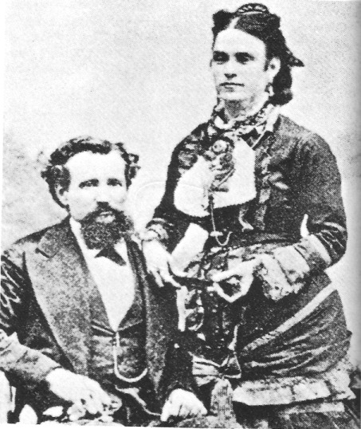
Aaron and Rosie Winters, early Ash Meadows residents and Amargosa–Death Valley prospectors (date unknown).- Nevada Historical Society

Winters Discovers Borax

The poverty experienced by Aaron and Rosie Winters was soon relieved by a stroke of luck. Borax was discovered in Death Valley in 1873, but even at $700 a ton the remote location made the deposits unprofitable; more accessible deposits to the west were worked instead. In 1881, news of the possible extension of the Carson and Colorado River Railroad south through Owens Valley and the Southern Pacific east across the Mojave had stimulated interest in borax in the dry lakes in the surrounding area. This news caused a handful of prospectors to seek out the mineral. One such prospector was Henry Spiller, who, while spending a night at Winters' ranch in Ash Meadows, told Winters about borax deposits in Nevada and the fortune awaiting the man who could find more borax. That evening Spiller took out a sample of borax and showed Winters how to test for it by pouring alcohol and sulfuric acid on the salt. Winters watched with attention, for he had remembered seeing a mineral in Death Valley that resembled what Spiller had shown him.
When Spiller left, Aaron and Rosie Winters went to the valley. They gathered likely looking samples, and that night tested them as Spiller had instructed. "At last, when the shadows had closed in around them, Winters put some of the salt into a saucer, poured the acid and alcohol on them, and with trembling hands struck a match. It was an anxious moment. Then he shouted, 'She burns green, Rosie! We're rich, by God!'" (Lingenfelter, 1986:174). Winters staked out his claims, and he eventually sold them for $20,000 to San Francisco borax magnate William T. Coleman, who at that time had a virtual monopoly on American borax. The claims became the Harmony Borax Works. Winters used the money to purchase the "even better-developed Pahrump Ranch" from Charles Bennett in May 1882 (Lingenfelter, 1986:174; Warren, 1980:225-226). Rosie died a short time later and Winters lost all but a small part of the ranch for taxes in 1887.
The Lee brothers, Phi and Cub, the Winters' former neighbors in Ash Meadows, went on to discover borax deposits that dwarfed what Winters had found. The Lila C. deposit, discovered by Phi and Cub, produced millions of dollars in borax, and the Monte Blanco, found by Phi and two partners, still holds several million tons of borax ore. Phi Lee and his partners sold their Monte Blanco claims for $4000. Phi used his share to buy the ranch at Resting Spring, where he resided until 1915.

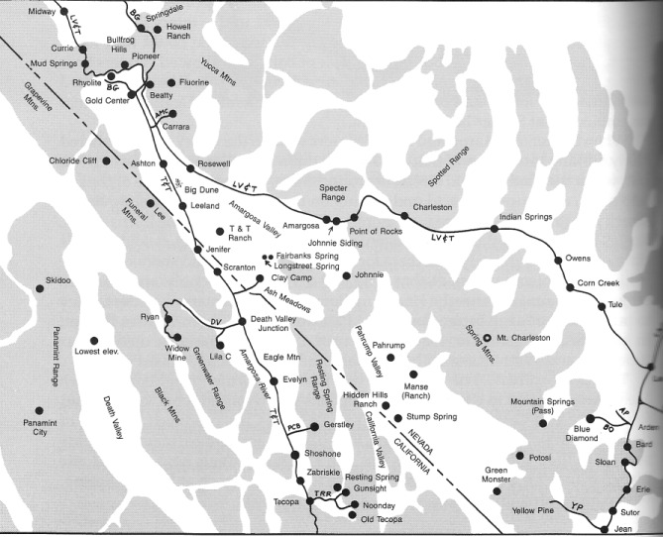
Railroads played a critical role in the development of the Amargosa Valley. Some of the more important ones in the region were the Bullfrog Goldfield (BG), the Las Vegas and Tonopah (LV&T), the Tonopah and Tidewater (T&T), and the San Pedro, Los Angeles and Salt Lake Railroad (marked as LA&SL). (The spellings of some place names on the map may vary from modern spellings.) Map by R. Gary Raham (after Myrick 1963)

CHAPTER THREE
Arrive in the
Amargosa Valley

In the early 1900s the Amargosa Valley had few resources that were of interest to the outside world. Thus, its fate was tied to economic developments that occurred elsewhere. In reality, the exploitation of mineral deposits in Death Valley, the discovery of silver and gold in the Tonopah-Goldfield area, the founding of Las Vegas in 1905, and the short-lived Bullfrog district boom all were important in the next phase of the history of the Amargosa Valley.

Clark Builds the Las Vegas and Tonopah Railroad

In early 1905, Senator William A. Clark of Montana completed his San Pedro, Los Angeles and Salt Lake Railroad (SP,LA&SL), linking southern California with Salt Lake City and the Union Pacific in Utah. The railroad town of Las Vegas was founded in May. Almost immediately, it became the focal point of plans for railroad link-ups to profitable mining areas. Tonopah and Goldfield were developing rapidly—a railroad line via Las Vegas to southern California was bound to be profitable. Francis Marion "Borax" Smith, who first attempted to link Las Vegas and Tonopah by rail, was forced to abandon his plans when Clark refused to grant him any connecting rights to the SP,LA & SL at Las Vegas. Clark took over Smith's Las Vegas railroad operations, including initial grading that had been completed, and began construction of his own line, the Las Vegas and Tonopah Railroad (LV&T).
Clark's new railroad headed north out of Las Vegas and made a number of stops before it passed through the Point of Rocks gap west of present-day Mercury and entered the Amargosa Valley. There were several stops within the valley itself, including those at Johnnie Siding and at Amargosa (both at the base of the Specter Range), and at Rose's Well northeast of the Big Dune. Passenger service from Las Vegas to Beatty was inaugurated in October 1906. When finally completed, the railroad reached Rhyolite and Goldfield. The LV&T ceased operation 11 years later on October 31, 1918; the Nevada Department of Highways purchased the rights to the roadbed between Las Vegas and Beatty, and Highway 95 between those two points follows much of the old LV&T route.

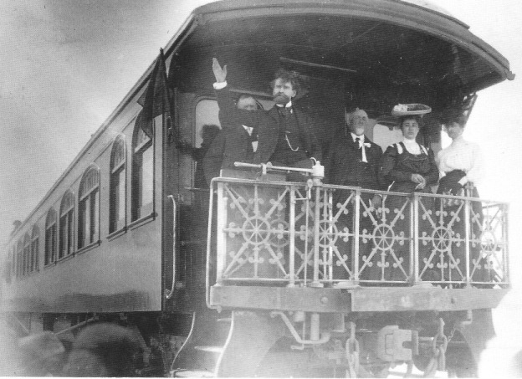
Senator William A. Clark on his private railroad car (date unknown). - University of Nevada. Las Vegas—Dickinson Library Special Collections—Ferron-Bracken Collection

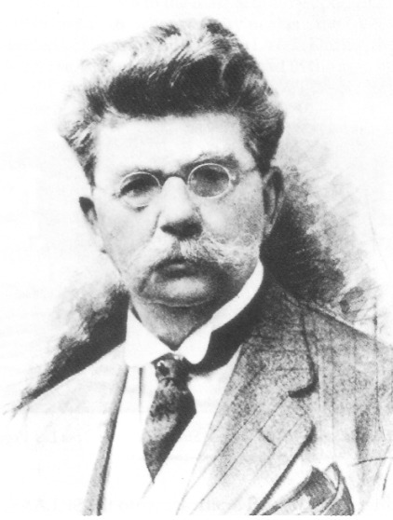
Francis Marion "Borax" Smith, who formed the Pacific Coast Borax Company in 1890, played a major role in the economic development of the Amargosa Valley - University of Nevada, Las Vegas - Dickinson Library Special Collections

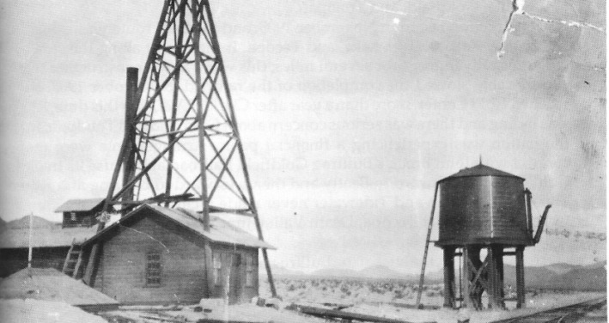
Photo (circa 1910) of either the Amargosa Siding or the Johnnie Siding in the Amargosa Valley on the Las Vegas and Tonopah Railroad. The hills in the background resemble those that surround Ash Meadows. The Johnnie Siding was located about where the Pahrump highway (Highway 160) takes off from Highway 95 in the Amargosa Valley. The Amargosa Siding was about 5 miles to the west of the Johnnie Siding. Nye County Town History Project—Lowe Collection

Borax Smith and the Tonopah and Tidewater Railroad

In 1872 Borax Smith discovered borax ore at Teel's Marsh located west of Tonopah, Nevada. In 1890 he acquired William T. Coleman's borax holdings in Death Valley and Borate (Calico), California; that same year, he formed the Pacific Coast Borax Company. After 1900 the Calico ore began to run low and Smith planned to turn to deposits at the more remote Lila C. Mine in Death Valley. To profitably exploit these more inaccessible resources, he needed a new rail connection. Smith therefore incorporated his Tonopah and Tidewater Railroad (T&T) in 1904; and in 1905, he shifted his base of operations from Las Vegas to Ludlow, California, where he could connect with the Santa Fe Railroad after Clark denied Smith access to the SP,LA&SL at Las Vegas. Smith was still determined to build a line to his Lila C. and also northward to the boomtowns of Rhyolite, Goldfield, and Tonopah.
Construction began in November 1905, and the T&T route was extended to Soda Lake, Razor, Silver Lake, and Tecopa. It then went along the side of the Amargosa River gorge for several miles; this was a major construction feat and considerably slowed the completion of the railroad. By October 1907, the line reached Gold Center, more than a year after Clark's LV&T. By this time, Rhyolite was fading and there was serious concern about Goldfield and Tonopah; further, the nation was experiencing a financial panic. Arrangements were made to connect with John Brock's Bullfrog Goldfield Railroad and to use its track from Gold Center northward to Beatty and then westward to Bullfrog and Rhyolite. Thus, the Tonopah and Tidewater never made it close to Tonopah. Spur lines were constructed at Tecopa, Death Valley Junction, the Lila C. Mine, and Ash Meadows.
Unfortunately, the bust of the Bullfrog district and the decline of Tonopah and Goldfield in the 1920s and 1930s resulted in the eventual closure of all the area's railroads and their spur lines. The Bullfrog Goldfield shut down in 1928. By 1930, it was still possible to travel by train from Beatty to Los Angeles, but only once per week. Tonopah and Tidewater operations continued in the 1920s and 1930s, but revenues were disastrously low in the latter decade and all operations ceased on June 14, 1940 (Myrick, 1963:593). The Amargosa Valley no longer was the scene of any railroad activity.
Both the T&T and the LV&T were important to the marble quarry operations at Carrara at various times. In 1915 and 1916, when activity peaked, the LV&T served the quarry. Operations folded before the demise of the LV&T. During the late 1920s operations were revived; the T&T was the only railroad in the area by then, and a 3/4-mile spur was built across the valley from the T&T tracks to a siding at Carrara in 1927. The branch was dismantled in 1932.

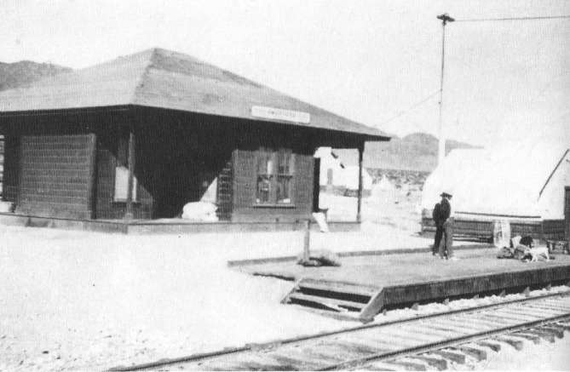
The station at the Amargosa Siding located on the Las Vegas and Tonopah Railroad (circa
1910). Nye County Town History Project—Lowe Collection

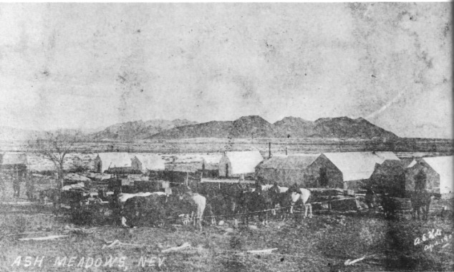
The community established by Ralph Jacobus "Dad" Fairbanks at Fairbanks Spring, Ash Meadows. Tent buildings are visible (circa 1907). Nye County Town History Project—Lowe Collection

CHAPTER FOUR
The Early 1900s:
People and Place

By the early 1900s, the population of the Amargosa region had begun to grow. Growth brought an increase in opportunity for enterprising people. Freight was being moved north to Tonopah and to camps in the Death Valley area. Virtually every water hole was occupied. The proliferation of camps provided a succession of opportunities for miners, merchants, and desperadoes. In the Amargosa, formerly worthless deposits of clay soon became valuable.

"Dad" Fairbanks

Ralph Jacobus "Dad" Fairbanks is one of the best-known individuals in the history of the Amargosa-Death Valley region. He was born in 1857 in Payson, Utah, the tenth child of Mormon parents from Massachusetts. While still a child, he moved with his parents to St. Joseph on the Muddy River in Nevada. During his years in St. Joseph, he made several trips with his father to the Gass Ranch in the Las Vegas Valley, once in the company of the famous Mormon missionary Jacob Hamblin (C. Lowe, 1988).
When Fairbanks was ten, his family returned to their farm in Payson. As he matured, he worked at a variety of jobs; he was employed for a number of years at the Payson Mercantile Store, which he later remarked provided him with the best education of his life. When he was 18 years old he and one of his brothers signed on as swampers on a wagon train bound for San Bernardino. The trip west of Las Vegas was the beginning of an intimate association with that desert region.
In 1883 Dad and an older brother were called by the Mormon Church to help establish a new colony on the Sevier River in southern Utah. There he filed on a homestead in the newly created community of Annabella, not far from Richfield, Utah. He married his childhood sweetheart, Celestia, and soon the couple and their young children established a home at Annabella. He acquired the name "Dad" because Indians often heard Celestia and the children address him as "Dad" and assumed that was his name.
Though the Fairbanks family had a good home and plenty to eat, Dad was not satisfied with opportunities for money-making in the community. He desired a more prosperous life. By about 1902, Senator Clark was in the process of constructing his SP,LA&SL Railroad, which would connect Salt Lake and Los Angeles. Dad, who was an expert teamster and always interested in new enterprise, obtained contracts for hauling and grading on the SP,LA&SL Railroad. When that railroad was completed, Dad obtained hauling and grading contracts on Clark's Las Vegas and Tonopah Railroad between Las Vegas and Beatty. Once the railroad reached the Amargosa area, Dad and his sons also hauled ore from nearby mines to the closest railheads as well as supplies in and out of Rhyolite.
During this period Dad purchased the Ash Meadows spring and nearby land, which now bears the Fairbanks name. At his Fairbanks Spring Ranch, he established a mercantile business known as Fairbanks Mercantile and a freighting business between the railhead at Johnnie and the booming community of Greenwater.
At his mercantile store, which functioned as a trading post, Dad Fairbanks sold various mining supplies, including picks, shovels, dynamite—anything a miner might need. He also sold hay, grain, and feed. The ample pasture in the area also offered grazing for Dad's stock as well as the animals of travelers. Dad also grubstaked substantial numbers of prospectors, an enterprise in which he engaged until his last years. He also ran a boardinghouse in conjunction with the freighting operation.
Once established at Fairbanks Spring, Dad sent for his wife and daughters, who had remained in Annabella. The family traveled from Annabella to Cove Fort, Utah, by wagon; there they boarded the train to Las Vegas, where they spent the night in the Overland Hotel. The next day they boarded an open-air flatcar on the LV&T for the ride to Johnnie Siding, where Dad was to meet them.
At Fairbanks Spring there were trees and plenty of grass and water. Dad had set up a tent for Celestia and the girls and the business was going strong, with work for everyone. In fact, with the extra help, business prospered. Hay was sold by the ton and gasoline was stocked in 5-gallon tin cans. In addition to the store and a barn (both tents), there was a tent that served as a restaurant and a 1905 version of a motel, a row of tents where travelers could stop and sleep overnight. Celestia served as the cook for the restaurant and the boardinghouse, a job she kept regardless of where the family moved.
In about 1908, Dad instituted the first in a series of moves—relocations dictated by changing economic conditions. He started a business in Greenwater, then left for Shoshone in 1910. In 1916, at the age of 60, he made his long-hoped for "mining strike," not of gold, but of filtering clay needed for refining petroleum. He sold out in 1920 for a "tidy fortune." In 1926 he purchased land in Baker, California, and in 1928, when he was past 70, he established yet another mercantile business there—the fourth community he had helped found. Dad Fairbanks, a pioneer of the desert who had once played with the son of Chief Tecopa, the last of the Paiute chiefs, in the Las Vegas Valley in the 1860s, died in Hollywood, California, in 1943.

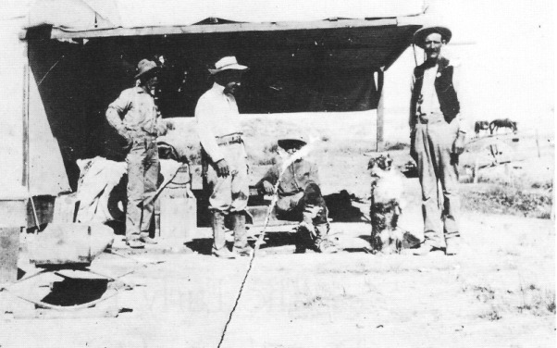
Fairbanks Spring, Ash Meadows, between 1906 and 1907. "Dad" Fairbanks is on the far right. All the structures were tents - Nye County Town History Project - Lowe Collection

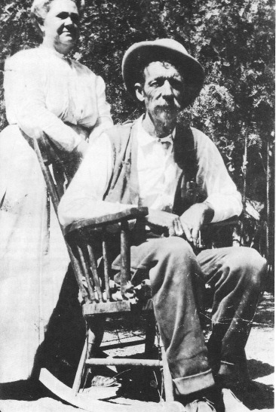
Celestia Adelaide Johnson Fairbanks and her husband, Ralph Jacobus "Dad" Fairbanks (circa 1920). Everybody called them Ma Fairbanks and Dad Fairbanks. - Nye County Town History Project—Lowe Collection

A Child's Diary: Life at Ash Meadows

When Stella Fairbanks was thirteen years old, she lived with her parents, Ralph and Celestia Fairbanks, and her brothers and sisters at Fairbanks Spring, in the small Ash Meadows community her father had founded. Young Stella, who had very little formal education, kept a diary. The excerpt presented here relates events in her life from mid-November to Christmas 1906. During this period, Stella contracted typhoid fever and the Fairbanks celebrated Christmas at their Ash Meadows home. The passage—exhibiting a child's charm and unpretentiousness—provides a rare view of a way of life and a community that no longer exists.

Nov. 14 There was a steem otto [steam-powered automobile] come after night with 3 on it. We had lots of men here for every meal.
Nov. 19 Ma was sick again to day and the wind blew awful hard and it was just as cold as it could be.
Nov. 30 Mr. and Mrs. Coonzie were here early in the morning in a otto but they went rite on.
Nov. 31 I didn't feel well all day and I washed the dishes anyway if I was sick.
Dec. 2 I was in bed all the day and never had nothing but supe. There was 1 otto here.
Dec. 3 There wasent any ottoes here all day. I ate hearty all day and they would give me anything I wanted.
Dec. 4 There was a women and her little girl stayed here all night the girl wasent very little she is 16 years old but I am bigger than she.
Dec. 7 I was so tired of laying in bed but couldent get up.
Dec. 8 Mildred Mrs. Bakers little girl was sick to. And Ralph wes sick. There he was quite sick. There wasent any ottoes here to day.
Dec. 9 Ma killed a chicken to day but I coulden't have any of the meat I could just have the brothe.
Dec. 10 Pa went to the Vegas to day to get the Doctor. Lester went to the sideing and dident come back for three days. Ralph was to sick to go.
Dec. 12 Pa and the Doctor came to day. They brought a little thing to test the feaver. He tested mine I was 102 and he hold Pa that I had the typhoid feaver. Pa brought apples, oranges, nuts, bannas, tomatoes and everything nice but I couldn't eat any of them.
Dec. 13 I was in bed all day long but don't like to lay in bed. The boys ate the apples and Ma and Celesta Vonola ate the tomatos but I put the nuts in my trunk and is going to eat them on Xmas. Dec. 14 I have all kinds of supe and oranges and puddings and custards. Dec. 16 There was a steem otto here to day where Dave and Lester come down from the sideing brough a great big box of apples but the boys have got them all ate up now.
Dec. 18 I set up to day in the rocking chair and Ma combed my hair. I got a new coat and 2 new skirts.
Dec. 19 I set up an hour to day. Ma cooked a chicken and I had the brothe. Mr. Jackson brought me 2 oranges and a lot of dates and 3 bannaws.
Dec. 20 Today I set up for 3 hours. On Xmas Pa said I could have an apple and eat some nuts. There was a woman and a little boy 12 year old stayed here all night. They were going to green water.
Dec. 21 I got up early this morning and dressed me and set up nearly all day. The women and the little boy wen on this morning.
Dec. 24 Mr. Lisle brought me a lovely Xmas present and he gave it to me to¬day it was a work basket with the lovely bottles of sent one rose and one violet.
Christmas Day When I got up this morning I had a box of riting tablets and an orange and apple, candy and nuts. Vonola got a doll and a story book and candy nuts. Mamma got a work basket and I gave poppa a shaving out-fit, we had a big turkey dinner and I went in the dining room to eat my dinner but I couldn't have any of the turkey, and at night all the folks came.

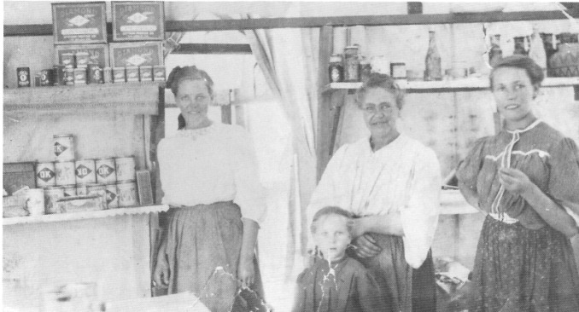
Stella Fairbanks (right) with her mother, Celestia Johnson Fairbanks (center), and her two sisters, Celesta (left) and Vonola (in foreground). The photo was taken in the tent store and cafe at Fairbanks Spring, Christmas 1906. Photo and text of diary courtesy of Celestia Gilliam, Stella's daughter.

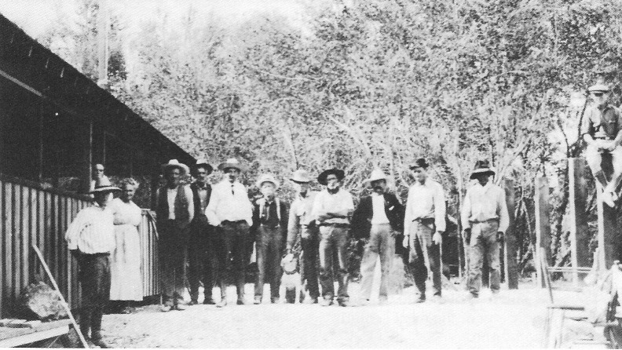
Photo (circa 1915) showing Celestia (on the left in the white dress) and Dad Fairbanks (to the right of Celestia), who constructed a boardinghouse (left) at Shoshone, California, in 1910. Passengers on the Tonopah and Tidewater Railroad and local miners and prospectors often took meals there. Shorty Harris, the co-discoverer of Rhyolite (the short man wearing a white hat and suspenders in the middle of the line to the left of the dog) was a long-time friend of the Fairbanks. Herman Jones (the man to the right of Shorty Harris) and Harry Oakes (sitting on the post on the far right) were once grubstaked by Fairbanks, who gave them each $500 worth of groceries and supplies. Oakes had fallen in love with Fairbanks' daughter Stella. When Oakes asked for Stella's hand, Fairbanks turned him down because he didn't think the young man would amount to much. Later Oakes went to Australia to work for a mining company and became very wealthy. In the 1940s, Oakes returned to the Amargosa-Shoshone area, driving a Rolls Royce. He flourished a $1000 bill and paid back Fairbanks for the grubstakes. Charley Brown (third from the right) eventually married Stella. Nye County Town History Project—Lowe Collection

The Ash Meadows Clay Operations

Word of Dad Fairbanks' discovery of filtering clay in 1916 spread quickly and many others staked out claims. S. Frank Brock, a mining engineer, discovered an immense deposit and staked claim to over 6 square miles. These clays, primarily hydrous magnesium silicates, were useful in cleaning or clarifying heavy oils. The southern California oil boom was in full swing, and by 1925 Brock had convinced several companies to purchase claims.
Some of these companies, including General Clay (a subsidiary of General Petroleum), began quarrying Ash Meadows clay deposits by 1925. Production reached 1200 tons a month. Clay was removed from the pit, dried on platforms made of railroad ties, trucked to the Bradford Siding 3 or 4 miles away, and then transported on the Tonopah and Tidewater Railroad.
In 1927, one company, United Death Valley Clay, consolidated much of the clay production in the area. The firm's manager, G. Ray Boggs, brought in gas-powered shovels, laid baby-gauge rails, and used a locomotive and railroad cars to haul the clay. An old diesel submarine engine powered a plant that dried, ground, and screened the clay prior to shipping. Production increased to 5000 tons a month. In 1928, following the closure of borax milling at Death Valley Junction, the Pacific Coast Borax Company converted the mill to handle clay. There the product was dried, crushed, processed, and sacked; it was transported to market on the T&T. (Power generated at the mill also supplied electricity to the Death Valley Junction community; when the mill closed at 11:00 p.m., so did the town!)
Production at the Ash Meadows clay operations peaked from 1927 to 1929. Shipments ran more than 30,000 tons a year, valued at more than $1 million annually. The Depression and new developments in refining oil drastically reduced demand for the clay; but mining operations continued until the T&T Railroad was shut down in 1940.

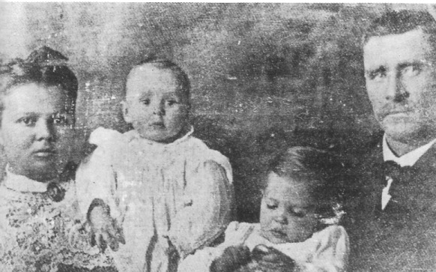
T.D.L. "Kitty" Tubb and Robert M. Tubb, Sr., and their sons, George and Robert (circa 1907), were early settlers in Ash Meadows. Kitty was called "Shotgun Kitty Tubb" because she never went anywhere without a shotgun. Nye County Town History Project—Goodson Collection

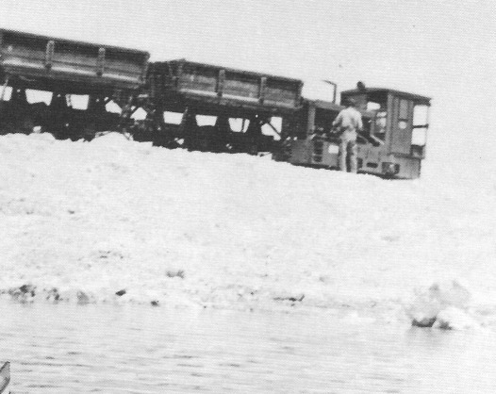
Ore cars and engine used at the clay pits, Ash Meadows (circa 1933). Nye County Town History Project—Toles Collection

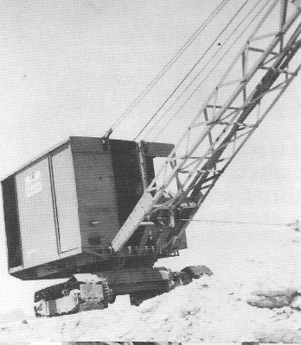
Dragline used at the Bell Pit, Ash meadows (circa 1933) - Nye County Town History Project - Toles Collection

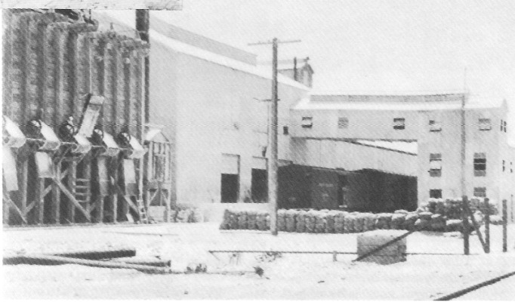
Borax milling operation, Death Valley Junction (late 1920's) - From Gower, 1969, courtesy Hank Records

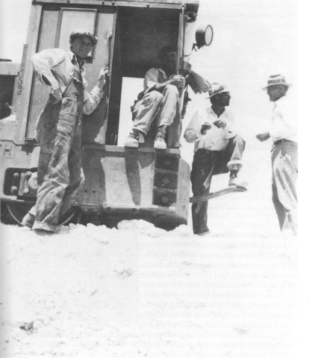
Members of the crew at the engine of the ore train used in the Bell Pit (circa 1933): (left to right) Glen Jepperson, dragline operator; Jess Toles, mechanic and engineer of the narrow-gauge train; Jack Pardee, dumpman; and Mac McKinna, miner and boss. - Nye County Town History Project—Toles Collection

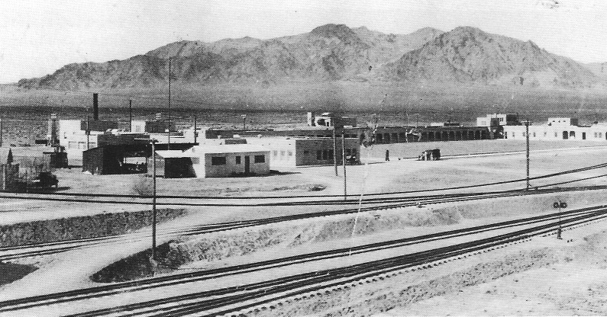
Death Valley Junction, California, 1924. Shortly after the hotel was constructed in 1924, the Pacific Coast Borax Company built a swimming pool and planted a number of trees in the square in front of the arches. The building on the left end of the square was the company store. An infirmary was established on the right end of the square. The tracks of the T&T Railroad are in the foreground; the Funeral Mountains are in the distance. - Nye County Town History Project—Lowe Collection

Life in Clay Camp

By the early 1920s a small community had sprung up in Ash Meadows to house the clay workers and their families. It was nothing fancy, a make-do place, not unlike the dozens of other mining camps in the area that had appeared and then quickly vanished in previous decades. Like so many of its predecessors on the desert, it was a tent town. It consisted of a row of tent houses situated near a marshy spot in Ash Meadows. Celesta Lowe was six years old when her family moved to Clay Camp, as the town was known. Her mother, Celesta, was Dad Fairbanks' daughter and had married John Q. Lisle, an Amargosa area prospector, in 1907. Lisle had staked clay-bearing claims in the Ash Meadows area and sold them prior to 1910. After moving to California, then to Ely and Fernley, Nevada, the Lisles returned to Ash Meadows in 1923.
The lower walls of the Lisle home in Clay Camp were constructed of 5-gallon cans, which the family members had filled with dirt and stacked; boards were buried in the ground along the wall to help hold the cans in place. The upper portions of the home consisted of canvas, and the interior was divided in half by a cloth partition; on one side were the beds and on the other side the living area. Boards were placed on the ground for a floor.
At the end of the row of makeshift tent houses (very appropriate dwellings in the hot, dry environment) was a large wooden warehouse that contained the offices of the mining company. There was also a schoolhouse, which cost $2500 to construct. It was made of wood and had windows and a tarpaper roof; money to build it was donated by Pan-American Oil President Edward L. Doheny. Celesta Lisle Lowe estimates that 12 to 15 students from the first through the eighth grades attended the school. Later the school was abandoned and the children were transported to Death Valley Junction; special arrangements were made with the State of California for their education. (In 1944 the schoolhouse at Clay Camp was moved to the Pahrump Ranch in Pahrump Valley where it was used by students until the early 1950s; efforts are under way to see that the structure is properly preserved.)
Social relations within Clay Camp are remembered as warm and cordial. It was common for people to bring their suppers to each other's homes and eat together. In the evenings, residents often sat in front of their homes; at least one person would play a musical instrument and the others sang. On Sundays, residents would gather for a picnic and swim in the pool at Crystal Springs. The nearest communities were Death Valley Junction, Shoshone, and Beatty. The Lisle family usually drove to Shoshone on Saturday evening, stayed overnight, and returned Sunday. In Shoshone there was a large swimming pool, which was used year-round (C. Lowe, 1988). South of the camp itself was another cluster of buildings, including a brothel.
Richard Lingenfelter, in his book Death Valley and the Amargosa, described a much more spirited community than the family-oriented camp remembered by some of its former residents, at least those who were children at the time:

Clay City [as Lingenfelter calls it] was a "rip-roaring" camp of close to a hundred roughnecks and camp followers, who boasted that it and its surroundings were the "toughest thousand acres left of the old West." It was a hodge-podge of boardinghouses, tin shacks, and tents clustered around a grocery store, several roadhouses, offering gambling and bootleg whiskey, and a row of cribs—all bent on relieving the men of their $5.50 a day as fast as they made it. Its isolation attracted several bootleggers, who set up their stills in the surrounding brush and ran their surplus to Las Vegas at night.
Clay City prided itself in having no police, jail, preacher, or graveyard. . . . For all its vaunted toughness, however, the closest Clay City ever came to real violence was the suicide of a despondent prospector who hung himself in the fall of 1927, and the tragic death of a Mexican laborer the following spring (Lingenfelter, 1986:410-411).

When Herb Toles came to Death Valley Junction from Colorado in 1931 with his father, Jess, there were several clay pits in the vicinity of Clay Camp, but only one was operating—the Bell Pit, located just south of the present American Borate Corporation (ABC) mill. The Associated Pit, west of the Bell Pit, was closed down, as was the pit and small mill operated by the Ballingers, father and son, located about 3 miles out into Ash Meadows west of the ABC mill. By this time, the camp was well past its prime. It consisted of two large buildings: a bunkhouse for the workers built from railroad ties and a frame house that provided living quarters for the superintendent and his family. A recreation hall, which the Associated Oil Company had previously built about 2 miles northwest, near where Jack Pardee lived, was also standing.

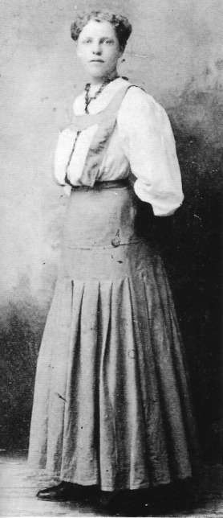
Celesta Adelaide Fairbanks, daughter of Dad and Celestia Fairbanks, at age 16 in Annabella, Utah (circa 1905) - Nye County Town history Project - Lowe Collection

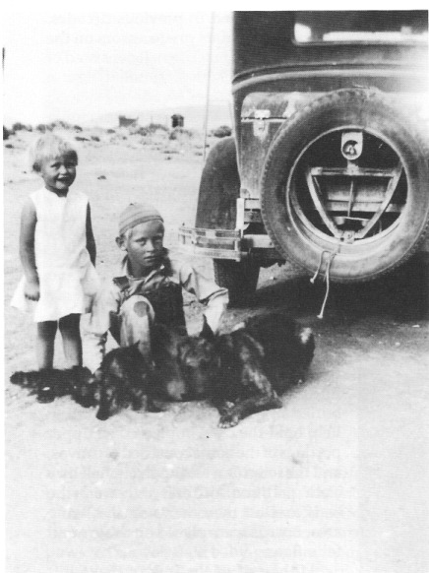
Louise and Tom Jepperson, whose father was the dragline operator at the Bell Pit, play with pets at Clay Camp (circa 1933). - Nye County Town History Project—Toles Collection

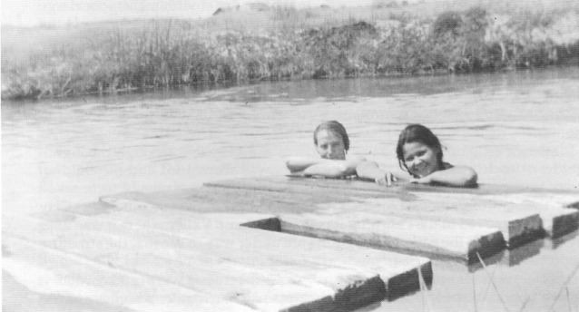
Children swimming in the pool at Crystal Springs, Ash Meadows (circa 1933). - Nye County Town History Project—Toles Collection

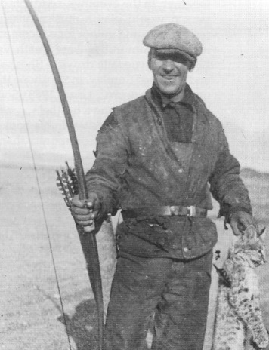
Jess Toles, father of Herb Toles and resident of Clay Camp, displays a bobcat taken with homemade bow and arrow (circa 1933). Toles and A. T. Shepperd, superintendent of the clay-mining operation, made their own bows and arrows and hunted bobcats, coyotes, and wild dogs. - Nye County Town History Project—Toles Collection

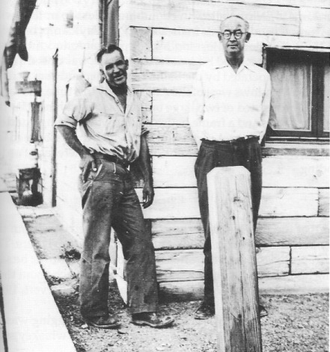
Clay Camp, Ash Meadows (circa 1940), was located several miles northeast of Death Valley Junction on the Nevada side of the state line. Jess Toles (on the left) and his family moved to Clay Camp in 1931. K. K. Miller (on the right) was a painter involved in remodeling the Amargosa Hotel at Death Valley Junction. The building in the picture was constructed of railroad ties from the T&T Railroad. - Nye County Town History Project-Turner Collection

Outlaw Country

Old-timers reported that the Ash Meadows area was outlaw territory from the time of the first entry of white settlers; a number of desperadoes lived there. The Tonopah sheriff was reported to have been afraid to go to Ash Meadows; he saw little to gain in risking his life. People from the area did not talk much about their past. The reputation of Ash Meadows lasted until the early 1930s (Revert, 1988; Toles, 1987).
During the Prohibition era of the 1920s and early 1930s, bootlegging was an important enterprise in the region. In 1931 there were at least six whiskey stills in Ash Meadows. The product was sold primarily in Las Vegas, but also in Beatty, Death Valley Junction, Furnace Creek, and Shoshone. Fred Davies ran a still in Ash Meadows, and one of his best customers is reported to have been the governor of California.
The making of moonshine in Ash Meadows sometimes resulted in violence and bloodshed. On at least one occasion, children living in the Ash Meadows Clay Camp were witnesses to the grisly aftereffects of murder. In the mid-1920s, burros abandoned by prospectors roamed in and around Clay Camp. A favorite pastime of the children was to put out feed to attract the burros, then catch, and ride them. The children and burros often headed for the refreshing waters of Crystal Springs, where the youngsters would swim before returning home. Ralph Lisle remembers a man in his fifties who lived in a cabin some 200 yards off the road that linked Clay Camp and Crystal Springs. The man had concealed a still in some mesquites about 200 yards from his cabin. The children sometimes delivered messages and ran errands for the man, who seemed friendly and generous and often gave them peppermint-flavored hard candies (Lisle, 1989).
One day the children and burros, on their way to Crystal Springs, stopped by the house, expecting candy. They knocked on the door; no answer. They knocked again; only silence. Sensing something wrong, they looked in a window near the front door and could see nothing unusual. They then walked around to the back of the cabin and peeked into the window of the bedroom. They were horrified at what they saw. There on the bed beside the window lay their friend, dead. His entire chest was torn open by a blast from a shotgun fired at short range. Somebody had stuck the gun in the window and killed him while he slept. The terror at what the children saw was magnified by the fear that the murderer might try to kill them. Quickly they climbed on their burros and rode fast for home. Once home they told Ralph's father, John Quincy Lisle, what they had seen. In 1989 Ralph Lisle stated that he did not recall that the murder was ever solved (Lisle, 1989).

CHAPTER FIVE
The Amargosa Valley
in the 1930s-1950s

During the 1920s and 1930s, the T&T Railroad was a focal point of most activity in the Amargosa Valley. The necessities of life arrived from the outside world on its tracks; the products of the valley—clay, marble, and some agricultural products—moved south on its rails. Most valley residents depended, directly or indirectly, on the railroad for their livelihood. Moreover, the T&T was held in great affection by those in every community it served; in contrast, many residents of Las Vegas—despite a similar dependency—disliked Senator Clark's SP,LA&SL.

Stops on the T&T Railroad

In 1930, after a train left Death Valley Junction and traveled north on the T&T tracks, the first stop was Bradford Siding, which consisted of a warehouse, a relic of the Bradford Mill, including the old diesel engine, and narrow-gauge tracks leading to the clay pits. The next stops, still located in California, were Scranton and Jenifer.
Leeland, the first stop inside the Nevada border, was a section point just south of Big Dune. In all, there were approximately ten sections along the T&T roadbed from Ludlow to Beatty. Leeland consisted of a small three- or four-room house occupied by the section foreman and his family, and four one-room units—one unit to a family—used by the section hands. There was no indoor plumbing or electricity and residences had cement floors. The foreman and workers were responsible for upkeep and repair of a designated section of track in the vicinity of Leeland. The section hands were nearly always immigrants from Mexico and most did not speak English. The wage for a section hand was $60 a month, and many sent large proportions of their pay home to Mexico.
After Leeland, Carrara was the next stop on the line. By the 1930s, nothing was left of the community of Gold Center, which was located just south of Beatty and was the original northern terminus of the T&T Railroad (D. Lowe, 1988).

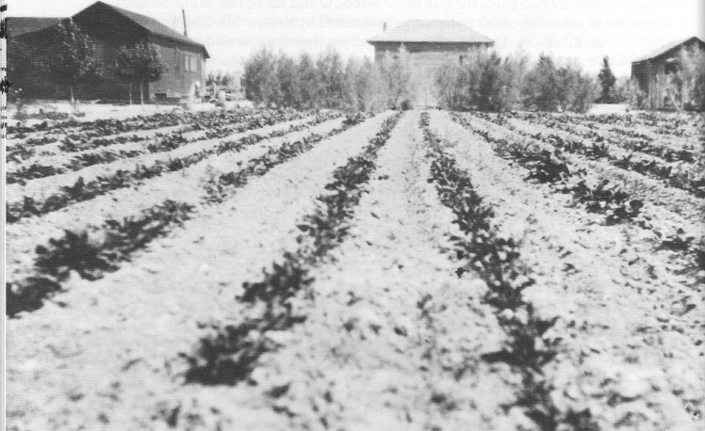
A field of sugar beets and buildings on the T&T Ranch, Amargosa Valley (circa 1920) - Nye County Town History Project - Fishel collection

The T&T Ranch—The Leeland Water and Land Company

For years following the completion of the T&T Railroad, the broad flat area of the Amargosa Valley lying northwest of Ash Meadows remained unoccupied. Yet experience at Leeland Station in the heart of this broad flat expanse demonstrated that the area was suitable for agriculture. Plenty of quality water was readily available from easily drilled wells, and vegetables and grain flourished in plots around the Leeland station house. Because company officials were always on the lookout for possible new sources of revenue, several trips through the area in 1914 and 1915 convinced them of the advisability of establishing an experimental farm near Leeland Station. If the agricultural productivity of the area could be proved, T&T officials reasoned, the tens of thousands of available acres in that part of the Amargosa Valley likely would fill up with homesteaders, all shipping their products on the T&T Railroad (Gower, 1969:28).
Harry P. Gower, a longtime employee of the Pacific Coast Borax Company, the company that owned the T&T Railroad, was selected as manager of the farm, with Walter Mayfield as his assistant. A couple of old shacks were moved down from Rhyolite to the farm, and months of cutting brush and clearing land began. A well was drilled, a pump installed, and a barn and corrals constructed in preparation for planting 10 acres in the spring.
The T&T Ranch operated under a succession of foremen but failed to attract other settlers to the valley because, as Gower (1969:29), said, the homestead laws were "just too tough to make it attractive in that desolate area for people of little means." Attempting to remedy that situation, company officials persuaded Nevada Senator Key Pittman to "push through Congress" legislation that enabled a U.S. citizen to acquire title to a section (640 acres) of arid Nevada desert land while continuing his activities elsewhere (Gower, 1969:29). Under the terms of the 1919 legislation, an applicant could reserve four adjoining sections of 'unreserved, unappropriated, nonmineral, nontimbered public lands of the United States in the State of Nevada not known to be susceptible of successful irrigation at a reasonable cost from any known source of water supply" (The Statutes at Large . , 1921:293). After establishing within two years that sufficient underground water had been developed to produce a profitable agricultural crop (not native grasses) on at least 20 acres, an applicant could acquire title to one-fourth (640 acres) of the land reserved in the permit (The Statutes at Large . . , 1921:294).
The only homesteaders to take advantage of the legislation for the Amargosa Valley were five officials from the Pacific Coast Borax Company. They were F. M. Jenifer, F. W. Corkhill, U. S. Miller, W. W. Cahill, and C. B. Zabriskie, for whom Zabriskie Point in Death Valley is named. Each claimed a section so that a large contiguous block of holdings was formed on the best land. The claims were eventually patented in 1927, and the deeds were signed by President Calvin Coolidge. The five "homesteaders" formed the Leeland Water & Land Company; land rights were then transferred to the borax company by the owners (Gower, 1969:30; Records, 1987).
Throughout the 1930s and until the closure of the railroad, there was a fair amount of activity on the T&T Ranch. A ranch house and a few outbuildings were constructed, and a number of wells were drilled on the property, ranging from 72 to 88 feet in depth. These wells provided an abundance of water, which was pumped 24 hours a day during the peak growing season. Amargosa Valley soil was productive when watered. Alfalfa was grown, and there was a small dairy on the property. Milk and vegetables were furnished to the Furnace Creek Inn, located in Death Valley, and to the Amargosa Hotel, at Death Valley Junction, both owned by the Pacific Coast Borax Company. Grapes were grown in great quantity, as were a number of fruit and nut-bearing trees. Yet despite the presence of water, good soil, sunshine, and transportation, it would be more than a decade after the closure of the railroad before serious farming activity was to begin in the Amargosa Valley outside of Ash Meadows. Of course, the slow demise of the T&T Railroad through the late 1920s and 1930s dashed all original hopes of making the Amargosa Valley an agriculturally productive area at that time.
In the late 1940s the road from Lathrop Wells to Death Valley Junction was paved. The construction company used the T&T Ranch to house some of its workers. Several buildings were brought in for the purpose and when the paving was finished the buildings remained on the property. In about 1948 Gordon and Billie Bettles obtained an option to purchase the T&T Ranch from the Pacific Coast Borax Company. Bettles was unable to execute the option's terms and in 1957 H. H. "Hank" Records, who had earlier obtained land in the valley under the Desert Land Act, obtained an option to purchase the ranch from the company. Records held the ranch until 1964 when he was forced to turn it back to the Pacific Coast Borax Company. Meanwhile, Bettles continued to occupy the ranch under Records' tenure; under the terms of the return, Bettles was allowed to keep 40 acres in gratitude for the effort he had invested in the ranch.

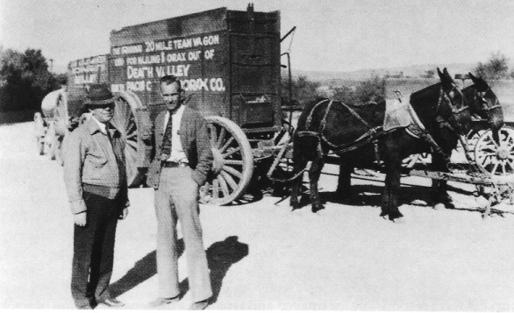
Harry P. Gower (right) with "Wash" Cahill, another executive of the Pacific Coast Borax Company (circa 1925). In the background are the 20-mule-team wagons once used to haul borax. From Gower, 1969. Courtesy Hank Records

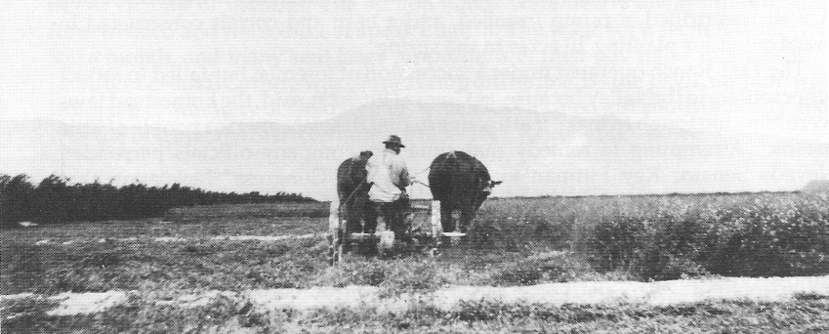
Cutting alfalfa with a horse-drawn mowing machine on the T&T Ranch, Amargosa Valley (circa 1920). Nye County Town History Project—Fishel Collection

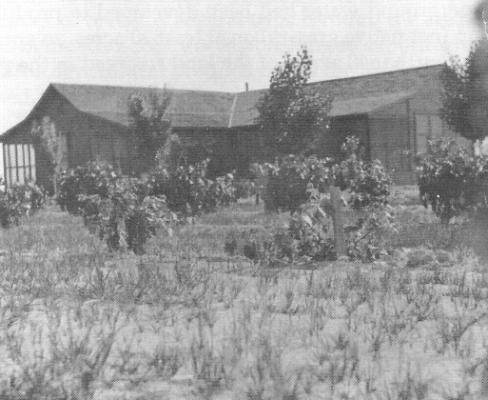
Grapes were grown in great quantities on the T&T Ranch. View of the original ranch house and grapevines (circa 1925). Nye County Town History Project—Fishel Collection

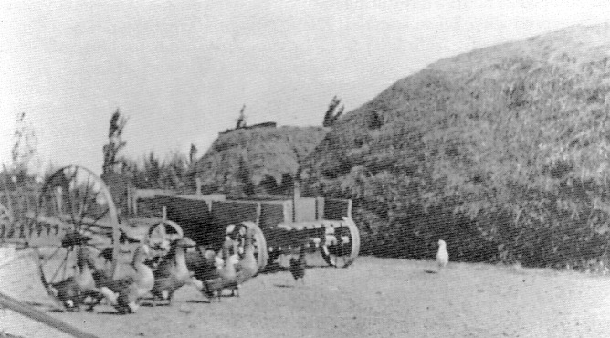
Wagons, haystacks, ducks, and chickens on the T&T Ranch (circa 1920). - Nye County Town History Project—Fishel Collection

Carrara, 1912-1941

The town of Carrara was founded in 1912 on the northeastern edge of the Amargosa Valley 3 miles down the mountain from the newly formed American Carrara Marble Company quarry. About 40 buildings were laid out near the LV&T tracks. The town's central attraction was a marble fountain, 18 feet across and 3 feet deep, with a 6-foot column of water piped from Gold Center-9 miles away.
The quarry was named after the famous marble obtained in the mountains of Carrara, Italy. Operations peaked about 1915 and 1916, when about 60 men were on the company payroll. However, operations ceased abruptly in 1916 when electrical service was abruptly halted. The company had faced increased competition from Vermont marble and artificial marble tiles (Myrick, 1963:606-607). Operations were briefly revived in 1927, and it was necessary to construct a 3/4-mile spur from the T&T Railroad to Carrara because the LV&T Railroad had folded earlier.
During the early 1930s, Carrara was described as "a nice little town." Company offices and homes constructed of wood lined a straight road that led up to the marble quarry, and the marble fountain still attracted the attention of visitors.
About 1940 a member of the Elizalde family (a Filipino family involved in the hemp business) became interested in Carrara. The young man, an engineer, intended to use the stone to make colored cement. Although by now both the LV&T and the T&T railroads had ceased operating, a mill was constructed. A clay dryer from the mill at Death Valley Junction was moved overland to Carrara. However, the mill never became operational. After Pearl Harbor and the beginning of World War II, the Filipino investors who supported the venture backed out and the operation ceased.

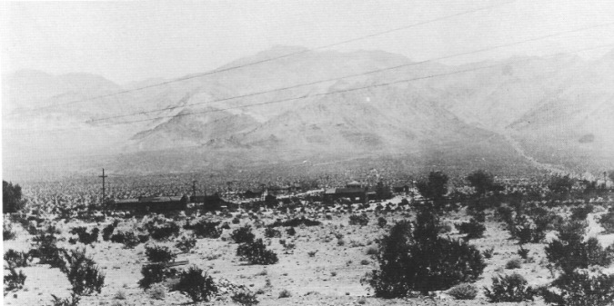
Carrara, Nevada (1920s). Nye County Town History Project—Palsgrove Collection

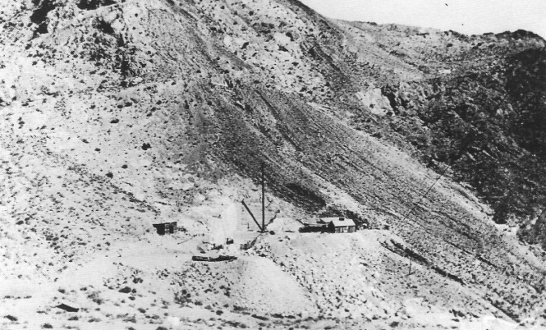
View of the marble quarry, Carrara (date unknown). Nye County Town History Project—Lemmon Collection

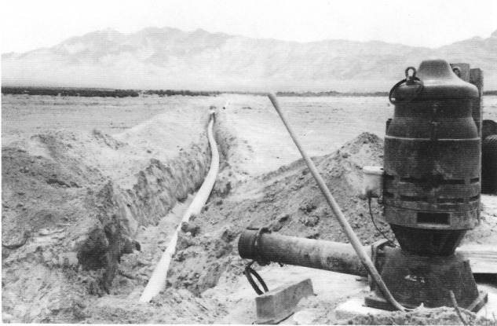
The development of the Amargosa Valley was advanced by projects such as this installation of a 10-inch water line and pump to supply a circle sprinkler system. The 75-horsepower electric turbine pump supports two sprinkler systems with a total of 1,450 gallons per minute. At that capacity, the pump only draws water down 3 inches in the well. Looking southwest toward the Funeral Mountains (circa 1980). Nye County Town History Project—Records Collection

CHAPTER SIX
Modern Development
of the Amargosa Valley

The modern era of Amargosa Valley development really began in the early 1950s, when the federal government opened the valley to settlement under the terms of the Desert Land Act. Prior to that time, the only people living in the Amargosa Valley resided in Lathrop Wells and the Ash Meadows area; Gordon and Billie Bettles lived on the T&T Ranch. Soon after, Hank and Robert Records took up residence nearby.

Gordon and Billie Bettles on the T&T Ranch

Gordon Bettles was born in 1893 in Helena, Montana. Bettles was a gregarious man who knew people throughout Nevada because he habitually stopped at diners for coffee while traveling. His natural friendliness led him to make many acquaintances. Billie, whose given name was Willie Odetta McElrath, was born in 1901 in Coleman, Texas, located south of Abilene, Texas. The couple first met at Clay Camp in Ash Meadows and were married in Tonopah in about 1927. Bettles, who had previously met Harry P. Gower, discussed acquiring the T&T Ranch with him; Bettles obtained an option on the T&T and in about 1948 moved to the ranch.
Gordon and Billie were the only residents in the Amargosa farm area; Edith and Frank Brockman (Gordon's oldest daughter and her husband) remember the Bettles' place as being quite spartan in the first years. Most of the trees and grape vineyards that had been planted on the T&T years earlier were dead. Gordon and Billie constructed a home from a tall, faded orange building that had once housed railroad workers. Around the house, Billie, who was a master gardener, created a garden about 200 to 300 feet wide full of trees, flowers, and vegetables (Brockman, 1987). They grew a wide variety of plants. The most important crop was alfalfa. Bettles held an option on the farm land, and he used the lovely alfalfa fields as a promotion to interest others in the area. To water the fields, he used a flood-irrigation system of siphon tubes, which had to be moved every 2-1 /2 hours. The water was pumped by diesel engines that ran continuously.
After the Bettles had been on the T&T Ranch for a few years, Pat and Gles Glessner, Billie's daughter and son-in-law, acquired 5 acres of Desert Land Act property at the junction of Mecca Road and the Lathrop Wells—Death Valley Junction highway. Beginning about 1955 or 1956, the Glessners built a home there. It had been their intention to retire in the area, but their plans changed. The Bettles acquired the property from the Glessners and moved from the T&T Ranch to the house on Mecca Road. In 1962 Bettles began construction of a building nearby that eventually housed the Mecca Club, but he died before he could complete it. Billie Bettles stayed on in the Amargosa Valley for a number of years and then moved to the Pahrump Valley.

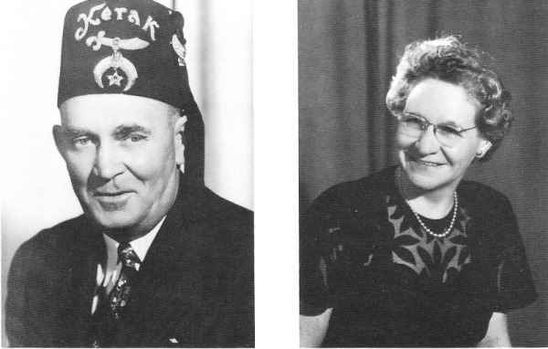
Gordon Bettles (circa 1950) and Billie Bettles (circa 1958) moved to the T&T Ranch in 1948. They renovated a building that was moved in from another site, created a garden, and planted hundreds of trees, flowers, and vegetables on the land. Their most important crop was alfalfa. Nye County Town History Project—Brockman Collection

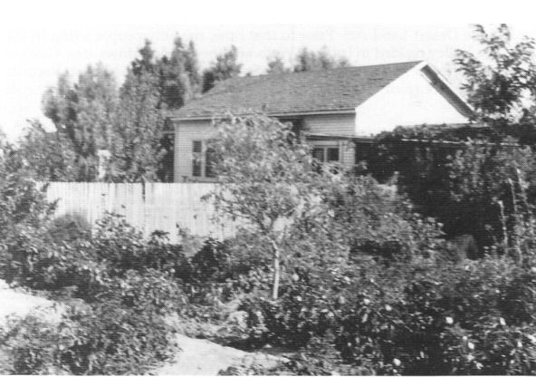
House and garden belonging to Gordon and Billie Bettles on the T&T Ranch (circa 1950). The site was bare land when the Bettles moved onto it. Billie Bettles' reputation as a gardener was well deserved. Nye County Town History Project—Fishel Collection

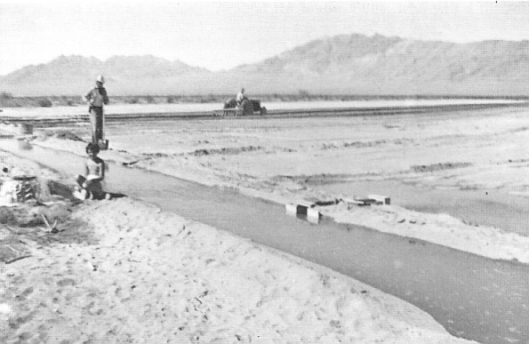
Irrigating newly planted alfalfa on the T&T Ranch (circa 1954). Gordon Bettles is holding the shovel. The child is Betty Lou Kemp. Nye County Town History Project—Fishel Collection

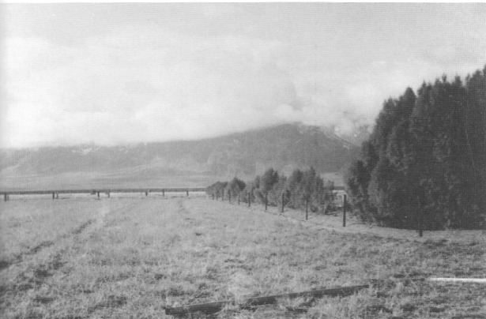
A landscape of fields and trees planted by Gordon and Billie Bettles on the T&T Ranch (circa 1955). Nye County Town History Project—Fishel Collection

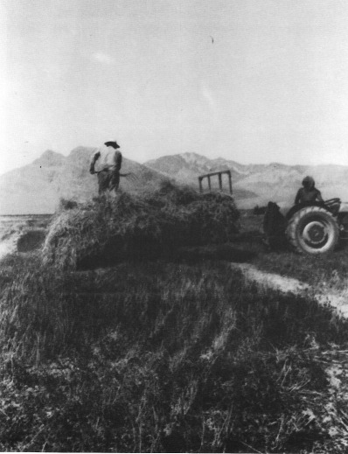
Gordon Bettles on the hay wagon and unidentified tractor driver on the T&T Ranch (June 1953). Nye County Town History Project—Fishel Collection

Modern Pioneers: The Records Brothers

Hank Records and his brother, Robert, were among the first to claim land in the valley under the Desert Land Act. The Records brothers grew up in New Mexico. Hank served in the Army in World War II and then worked in mining in Arizona and Death Valley.
Hank and Robert traveled across the Amargosa Valley in 1950 and were struck by its magnificent expanse. "That beautiful flat valley," Hank exclaimed. "Something should be done with it." Years later brother Robert jokingly commented, "That's when they should've put us in a straitjacket." Having grown up on a farm, both men appreciated the potential of the area.
Hank and Robert immediately looked into the possibilities of farming in the Amargosa Valley. Upon discovering that land was available under the Desert Land Act, they made a quick trip to Carson City to obtain the necessary papers. The Desert Land Act was designed to enable people to "prove up on," or develop, highly arid land; the terms were different than those of the Homestead Act. Under the Desert Land Act a person was allowed to claim 320 acres. In order to take title, one had to drill wells and prove enough water for the entire 320 acres, plant a total of 40 acres, and pay the federal government $1.25 per acre. Noting where the T&T wells were located and knowing their shallow depth, Hank and Robert and their families staked out Sections 24 and 19, while a friend took Section 18. The brothers were the first to officially file in the valley under the Desert Land Act (Records, 1987).
In 1953, the brothers returned to the Amargosa Valley with $30,000 and began drilling wells. They moved into trailer homes, began to clear the creosote brush from the land, brought in pumps and irrigation rigs, and then planted alfalfa and wheat. They grew wheat and alfalfa in the early years and sold the alfalfa locally, mainly at the Furnace Creek Inn. The Records were able to obtain six cuttings of alfalfa a year; they also raised replacement cows for the Jessop Dairy in Los Angeles. In the next few years they experimented with potatoes and other crops, including cantaloupes, watermelon, peanuts, and onions. Alfalfa was and remains the mainstay of agriculture in the valley, although experimentation continues, lately in pistachios and peaches and sod for lawns.
The Records brothers were followed into the valley by the Mankinens, the Stricklands, and the Selbachs. Many of the later arrivals, including the Stricklands and the Selbachs, supplemented farming with employment at the Nevada Test Site.

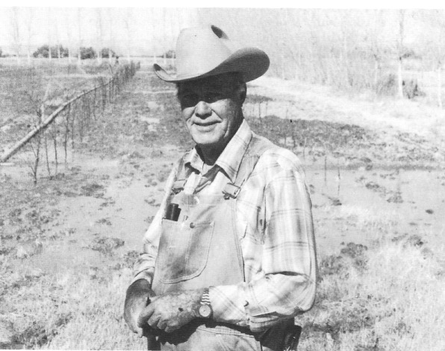
Hank Records (1989) and Robert Records (circa 1960) obtained land in the valley through the Desert Land Act. They drilled wells, cleared the land, and raised alfalfa, wheat, and a variety of other crops. - Nye County Town History Project—Records Collection

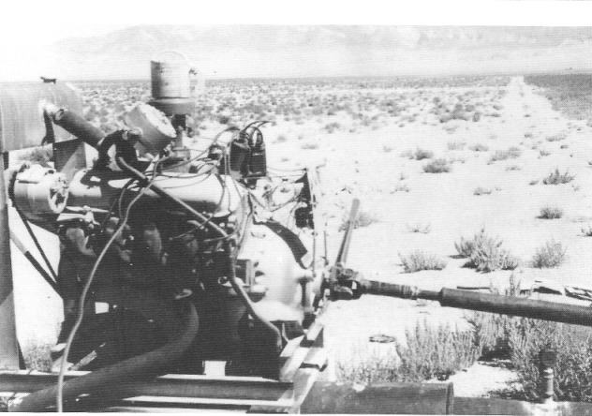
A butane-operated motor running a pump on Hank Records' property (circa 1958). Commercial electricity was not available in the Amargosa Valley until 1963. Before that date, all water was pumped by engines at the wells. Nye County Town History Project—Records Collection

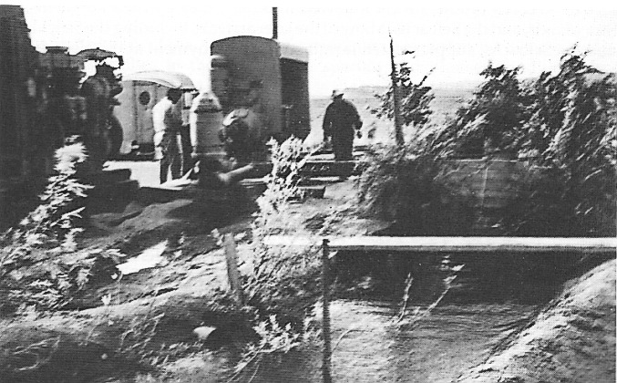
Diesel-electric power plants pumping water on Hank Records' property (circa 1956).
Nye County Town History Project—Records Collection

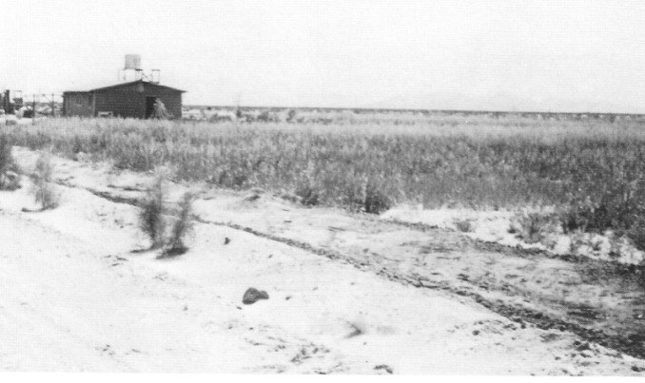
House moved by Hank Records to the T&T Ranch. Hank and Robert Records planted many varieties of trees on the property (circa 1955). Nye County Town History Project—Records Collection

Modern Pioneer Hardships

Like their predecessors, the first modern settlers in the valley endured many inconveniences and hardships. Killing frosts can occur as late as March, and wind conditions are at times severe. One of the most serious hardships was the lack of roads. Obtaining parts and repairs on farm equipment and vehicles was difficult. At that time, Las Vegas was a small community that was not oriented toward agriculture. Hank Records and the other pioneers had to think of Lancaster, California, nearly 200 miles away, as their parts and supply center.
Another problem for Amargosa Valley farmers—one that has not been fully solved to this day—is finding a market for their products. Although there is an abundance of water, and the soil is fertile and will produce virtually anything that grows, the nearest market is Las Vegas, which until recent years was relatively small. The next market of any size is the Los Angeles area, and it is nearly 300 miles to the harbor at San Pedro. Moreover, it is hard for small farmers to guarantee buyers large volumes of produce early in the development of their farms.
The first settlers of the Amargosa farm area also experienced difficulties in maintaining families in the valley. The spartan and pioneer conditions, in contrast to most parts of the United States in the middle of the twentieth century, were not to the liking of many women. As a result, household composition during this period was mostly male. Men were forced to leave their wives and children in cities such as Los Angeles and only visited them periodically (Records, 1987).
The hardships discouraged many individuals; they gave up and moved away. Old-timers have noticed that often no one individual is able to develop a farm. A pioneering person would come in, develop a farm to a point, and become discouraged or go broke and leave; later that person was followed by another farmer who made some additions and improvements to the place, only to become discouraged or broke. The process continued until a farm was fully developed and economically operated (Records, 1987).
In recent years, Amargosa Valley farmers have had to contend with new threats. Nevada state water officials have tried to restrict the pumping of groundwater by Amargosa farmers, arguing that restrictions are necessary to preserve groundwater resources. Valley farmers respond that the original well on the T&T Ranch, drilled more than 50 years ago, has not dropped more than 3 or 4 feet despite all the pumping during the past 30 years. Many residents believe that efforts to restrict water pumping in the valley is the first step in a long-term attempt by the state to expropriate groundwater resources in the valley for delivery to the thirsty city of Las Vegas.
Valley farmers also feel victimized by the federal government's policy of preservation of wild horses. Large numbers of these animals reside in the Amargosa Valley and are free to range on farmers' fields. Although farmers protest loudly to governmental agencies at every level, there has been little or no relief. In places, 25 or 30 wild horses range on a family's alfalfa fields, but the farmers cannot do anything about it.

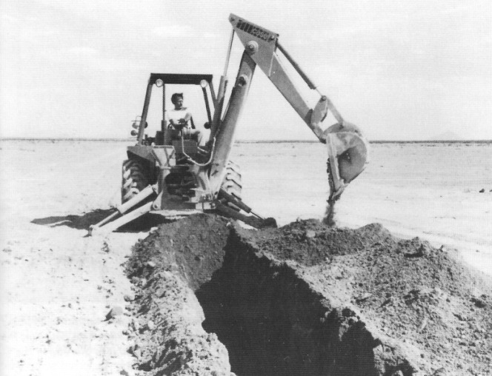
Digging a ditch to install a 10-inch water line to supply a sprinkler system in the Amargosa Valley (circa 1980). Nye County Town History Project—Records Collection

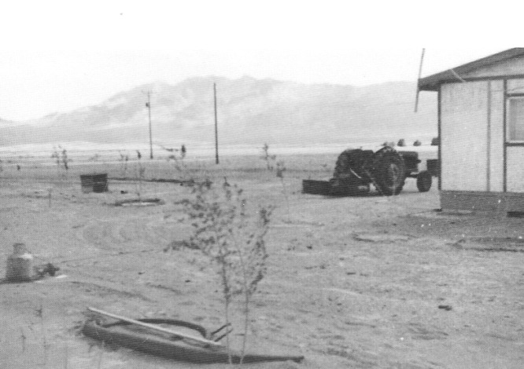
Looking southwest across the Amargosa Valley toward the Funeral Mountains (circa 1959). Some wives of the modern pioneers were not used to the spartan conditions. This house on the corner of Section 7 was constructed in Las Vegas; Hank Records moved it to this site in the Amargosa farm area. The trees in this picture were 50 feet tall in 1990. - Nye County Town History Project—Records Collection

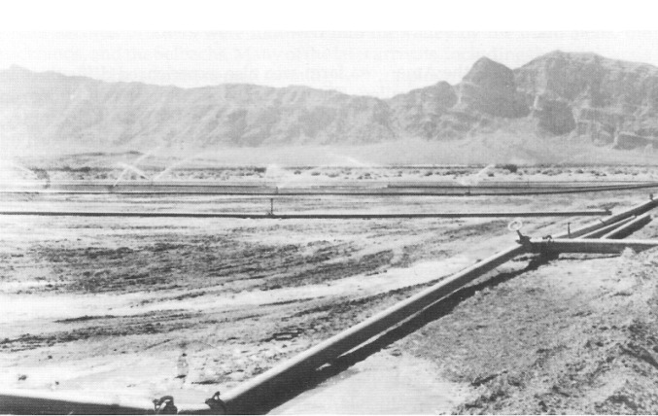
Irrigation pipes installed by Hank Records on his property (1974). The view is to the Funeral Mountains in the west. The profile of the sleeping old man can be seen along the crest of the mountains in the background. Nye County Town History Project—Records Collection

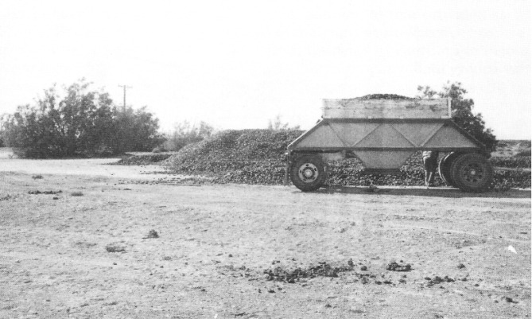
Alfalfa pellets produced on Hank Records' property (circa 1984). The trailer holds about 12 tons. Wild horses are a constant problem for the farmers in the Amargosa Valley farm area. They multiply rapidly and are protected by the federal government. This photograph shows the many horse tracks, droppings, and scattering of alfalfa cubes by horses the previous night. - Nye County Town History Project—Records Collection

The Struggle for Electricity

Amargosa Valley residents tried for years to interest the Nevada Power Company in extending service to the valley but they were always told that the cost was prohibitive. One evening in 1960, while sitting at their kitchen table, Hank and Robert Records decided to try to form an electric cooperative. They discussed the idea with valley residents Ed Mankinen, Ralph Dalton, and Gene Estabrooks and soon formed a nonprofit corporation: the Amargosa Valley Electric Cooperative. Hank Records then contacted Department of Interior officials in Washington, D.C., and officials from the Rural Electrification Administration (REA). Records realized that political clout and a strong case would be needed to demonstrate the community's need for electric power. He contacted officials at the Nevada Test Site and convinced them that the giant defense facility should have a backup supply of power in addition to that provided by the Nevada Power Company. Records then began signing up prospective customers in the Amargosa Valley. At the same time, residents in Pahrump formed an electric cooperative: the Pahrump Valley Utility Company. Both groups were advised that a merger would increase their chances of getting power; so the two entities joined forces. Ralph Dalton and Robert Records stepped down from the board of directors, and Elmer Bowman and Walt Williams from Pahrump became members.
Though they met with considerable resistance from the Nevada Power Company and Southern California Edison, the cooperative, with Hank Records spearheading the effort, secured 10,000 kilowatts of power from Davis Dam on the lower Colorado River. However, the cooperative soon realized that it would be too expensive to bring power from Davis Dam to the Amargosa Valley; when members learned that Hoover Dam power was fully allotted, a trade was arranged with an Arizona power company that held rights to Hoover Dam power. The Arizona company took over Amargosa's rights at Davis Dam, and the Amargosa Valley Electric Cooperative acquired rights to 10,000 kilowatts of power from Hoover Dam.
Soon thereafter, loan money became available through the REA, and power lines were strung from Hoover Dam across the Las Vegas Valley, over the Spring Mountains, and into Pahrump. From Pahrump the lines went to the Amargosa Valley, then on to Beatty and Sarcobatus Flat. Power for Fish Lake Valley was arranged through a trade with California power sources. Additionally, a line was furnished to Death Valley Scotty's Castle across the border in California from Sarcobatus Flat. The cooperative also supplied power to the Nevada state line, at which point it was picked up by Southern California Edison and distributed to Death Valley Junction and Furnace Creek. Power was turned on in the Amargosa Valley in 1963. The advent of economical electric power in the Amargosa helped initiate a new era of development. It substantially reduced the cost of pumping water and made the area more attractive for people to build residences and to operate farms (Records, 1987). Phone service was added in 1965.

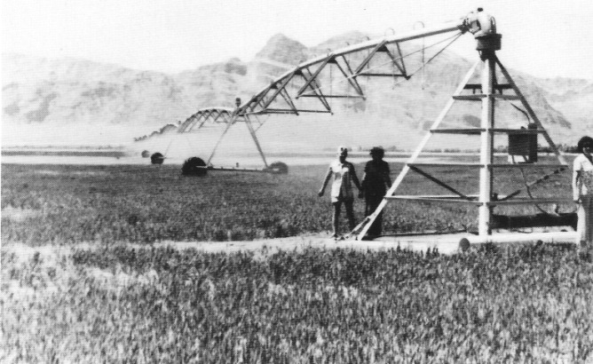
A pivot watering system was installed on Hank Records' property in 1980. Oats are planted as a cover crop for the alfalfa, which is just beginning to grow; later the oats are cut and the alfalfa
takes over. Nye County Town History Project—Records Collection

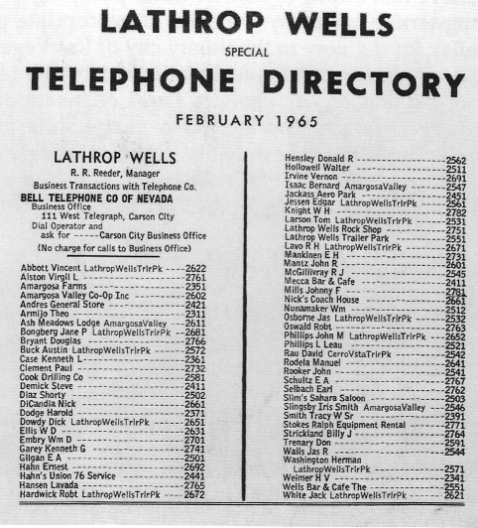
Phone Directory for Lathrop Wells (Amargosa Valley) (1965) - Central Nevada Historical Society

Modern Mining of Amargosa Valley Clays

Although the Ash Meadows Clay Camp was closed one year prior to World War II, exploration of Amargosa Valley clay deposits continued. In the 1960s, brothers W. Howard Prescott, Jr., and Edward P. Prescott formed a partnership. A man named Ewing had earlier acquired a number of claims on clay deposits in the valley, and the Prescotts acquired these as well as claims controlled by the Cappaert Ranch in Ash Meadows. In 1972 the Prescott partnership became incorporated, forming Industrial Mineral Ventures, Inc. (IMV). In 1977 IMV was acquired by Gulf Resources and Chemical Corporation of Houston, Texas (Hansen, 1987).
Though the Amargosa Valley contains vast deposits of commercially valuable clay, including some forms found nowhere else in the world, IMV's early efforts at refining were not very successful. The turning point came when it was discovered that the clays could be processed through extrusion. When the clays are extruded under high pressure through small holes in a die (not unlike the process of pressing pasta dough through a form nozzle), the small clay particles are sheared from one another, resulting in a high-quality product. With increasing processing efficiency, a high worker-productivity level was attained at the IMV plant located in the Amargosa Valley. In the 1980s, the plant was operating with 55-60 workers, down from 125 when methods of production were being established.
IMV mines different kinds of clay. Most of the mining operations are located near the Ewing Pit at the eastern edge of the valley. Other IMV clay pits are found west of the mill site, which is located 15 miles south on the Lathrop Wells—Death Valley Junction highway and 2 miles west on a dirt access road. Sepiolite, hectorite, and smectites are among the clays mined by IMV; the sepiolite deposit in the Amargosa Valley is the only known one in the United States. These salt-tolerant clays are used in drilling in the presence of salt water, for example, in an underground salt dome. (When drilling, clay is circulated in the drill hole under extremely high pressure, sealing off cracks in the drill hole. The circulating clay also removes the cuttings from the hole.) The sepiolite clays are also used in the manufacture of asphalt, roofing compounds, tape joint cement, stucco, latex, and spackling compounds. In Japan they are used as an asbestos replacement.
Hectorite is another type of clay mined by IMV in the Amargosa Valley. At IMV, hectorite is processed with a compound that includes steer fat and alcohol. In effect, the inorganic clay molecule is coated with an organic one in the processing. The organoclad clays (as they are called) produced by IMV are used in paints, greases, plastics, and for drilling.
Smectite, the third type of clay processed by IMV, expands in the presence of water. IMV combines bentonite, a smectite clay, with saponite; the product is used as drilling fluid, in stucco wall and ceiling coatings, and as fillers and sealants in the burial of chemical waste.
Another clay mining operation, which is very small by comparison, is located just west of the IMV plant at the base of the Funeral Mountains. The Vanderbilt Mine is the source of very fine-grained clays that are processed and sold by the pound to cosmetic producers. A smile comes to Amargosa Valley residents when they consider that there are people around the world who wear a bit of the Amargosa Valley on their faces when attempting to look their very best.

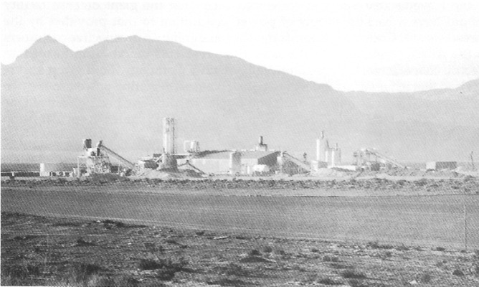
View of the mill of Industrial Mineral Ventures, Inc., located in the Amargosa Valley (late 1980s). IMV is a major producer of sepiolite, hectorite, and smectite clays, with a variety of uses in drilling and the manufacture of sealants, stucco, paints, greases, and plastics. - Courtesy Industrial Mineral Ventures.

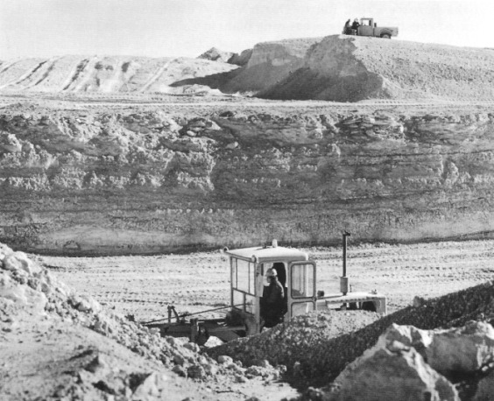
Mining sepiolite clay at Industrial Mineral Ventures' Morrett Pit, Amargosa Valley, Nevada
(late 1980s). Courtesy Industrial Mineral Ventures

The American Borate Company

In the early 1970s, Tenneco began operating a borax processing facility in the Amargosa Valley. Initially, colemanite, a calcium borate (borax) ore named for William T. Coleman, was obtained in an open pit mine, the Billy Mine, near Furnace Creek Wash, approximately halfway between Death Valley Junction and the Furnace Creek Inn in Death Valley. California environmental laws restricted construction of a processing plant in California, so a borax processing facility was built in the Amargosa Valley just across the Nevada border. The Billy Mine, which was located within the borders of the Death Valley National Monument, became depleted and the company was forced to mine the colemanite through underground mining techniques. A deep shaft was sunk outside of the national monument, and the colemanite ore was removed from the mine and trucked to the mill on the edge of Ash Meadows. Tenneco operated the mine and mill until about 1976, when it was sold to the American Borate Company (ABC) (Hansen, 1987; Jackson, 1987, 1989).
Two communities were constructed to house the mine and mill workers. One was located on the California side of the border in Furnace Creek Wash not far from the mine. It contained about 50 mobile homes and was known as the Valley Crest Park. The second community was constructed on the Nevada side of the border just south of the ABC mill near the Stateline Saloon. Known as the Stateline Trailer Park, it consisted of approximately 100 mobile homes. Additionally, many workers lived in mobile homes out in the valley on lots or small acreages. Other workers lived in Shoshone, Furnace Creek, and Pahrump, with a few commuting from as far away as Beatty. Between 1981 and 1983, employment at the mine and mill climbed to almost 500 workers. While it operated, American Borate contributed substantially to the valley's economy. A small shopping center was opened, apartment units were constructed, the Stateline Saloon expanded, and a branch bank was established. The mine's profitability, however, was adversely affected by the importation of colemanite products from Turkey at prices lower than production costs at the Amargosa Valley operation. The American Borate Company closed the entire operation in April 1986. In 1990, mine and mill operations reopened on a limited basis.

Peat Mining the Carson Slough

People had inhabited Ash Meadows for generations without seriously impacting the environment. But that began to change in the early 1960s when for three years the Carson Slough was mined for peat. When the mining was completed, bordering sand dunes were graded into the now-dry slough and mixed with the lower grade of peat that remained. The operation converted a large wetland area into dry agricultural fields, destroying a habitat for many species of aquatic insects, fish, and other animals, eliminating a "major wintering stop for waterfowl and other migratory birds" (Cook and Williams, 1982:IV-2), and depriving the state of one of its finest waterfowl hunting areas. Mining of the slough represented a significant degradation of the Ash Meadows environment and was followed by a controversial and, as it turned out, legally unacceptable first effort at large-scale agricultural development of Ash Meadows.

The Spring Meadows Ranch and the Pupfish Controversy

Prior to the late 1960s no real effort to practice agriculture in the Ash Meadows area on a large scale had been made. There was only small-scale production, and most of the land remained under the jurisdiction of the Bureau of Land Management. Then, in the late 1960s, Spring Meadows, Inc., exchanged 5400 acres in the Osgood Mountains for 5645 acres in Ash Meadows (Cook and Williams, 1982:1-1). Through additional purchases of private holdings in Ash Meadows, Spring Meadows, Inc., increased its holdings to 12,000 acres and garnered the majority of the area's water rights. Wells were drilled and the pumping of water began. Alfalfa fields were planted, and a large cattle operation—which provided jobs for more than 100 workers—was established.
Prior to this, naturalists had become interested in the area; in particular, biologists examined a number of species said to be endemic to Ash Meadows. Experts contended that Ash Meadows had the second highest incidence of endemic species of plants and animals found in North America. (A locale in central Mexico was first.) Of special concern were a number of dwarf fish species known as pupfish, in particular, the so-called Devils Hole pupfish. It was known to reside only in Devils Hole—a deep hole on a hillside in Ash Meadows that was fed by groundwater; the pupfish was readily identifiable by its small size, lack of pelvic fins, and by a dorsal fin placed far back on its spine. The Devils Hole pupfish was thought to have lived in isolation at the site for thousands of years, since the Great Basin began drying up about 10,000 years ago. Other species of pupfish found in Ash Meadows include several varieties of the Warm Springs pupfish, Ash Meadows pupfish, and a minnow known as the Ash Meadows speckled dace. Other endemic species in Ash Meadows include a beetle, a snail, and several plants, including two from the sunflower family and one each from the goosefoot, pea, loasa, and rose families (Cook and Williams, 1982:Chapter II).
Most attention, however, was focused on the Devils Hole pupfish. In 1952, President Harry Truman proclaimed Devils Hole a disjunct part of the Death Valley National Monument. In 1962 the National Park Service installed a device for measuring water-level fluctuations in Devils Hole in anticipation of future agricultural developments. As water pumping associated with ranching in Ash Meadows increased in the late 1960s and into the 1970s, water levels in Devils Hole and other springs in the meadows dropped, and many naturalists contended that endangered species, notably the pupfish, were being further threatened. (In mute testimony to early residents' opinion of the Ash Meadows pupfish, one of Dad Fairbanks' daughter's favorite pastimes was to catch them and feed them to her cat.) The controversy between the naturalists and ranching interests ended up in court, and on June 7, 1976, the U.S. Supreme Court stated that the government had the right to maintain water levels in Devils Hole because it was a part of the Death Valley National Monument. In 1978 a minimum allowable level of water was established at Devils Hole.
As a result of these decisions, the Spring Meadows Ranch was put up for sale. The ranch was offered to the U.S. Fish and Wildlife Service, and though the State of Nevada offered to share in the cost of the ranch's purchase, the offer was turned down. In 1980 the Spring Meadows Ranch was sold to Preferred Equities, a land development company based in Pahrump. Preferred Equities made additional purchases of land in Ash Meadows, bringing total ownership to about 17,000 acres, and it moved forward with plans to subdivide its holdings in Ash Meadows, anticipating the eventual development of a community of 50,000. Environmentalists, including the National Wildlife Federation, the Audubon Society, and the Sierra Club, learned of the plans, and a move was mounted to block further development.
In the early 1980s, The Nature Conservancy, a national conservation organization, purchased 12,613 acres of land and water rights owned by Preferred Equities in Ash Meadows. In 1984, the U.S. Fish and Wildlife Service purchased the Conservancy's Ash Meadows interests, permanently withdrawing an enormous amount of the best-watered part of the Amargosa Valley from development.

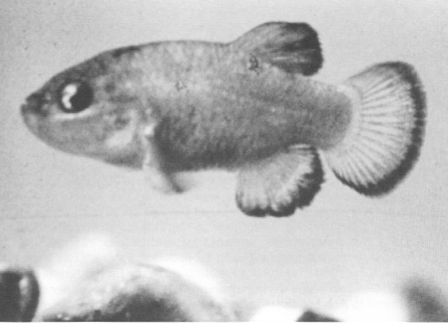
The Devils Hole pupfish (Cyprinodon diabolis), male, 1-inch long. Photo by Jack Williams. Courtesy James E. Deacon—University of Nevada, Las Vegas

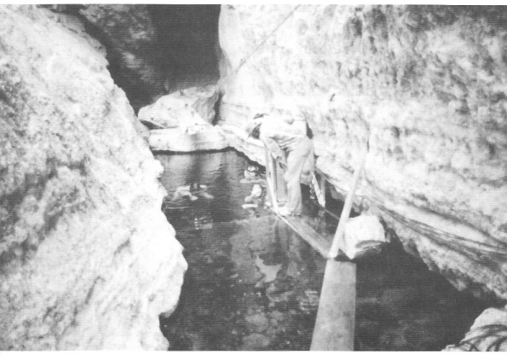
Photo of Devils Hole (circa 1983). Photo by W. R. Courtenay. Courtesy James E. Deacon—University of Nevada, Las Vegas

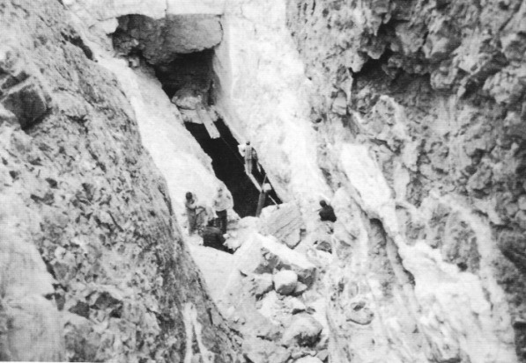
Photo of Devils Hole from above (circa 1983) - Photo by W. R. Courtenay. Courtesy James E. Deacon - University of Nevada, Las Vegas

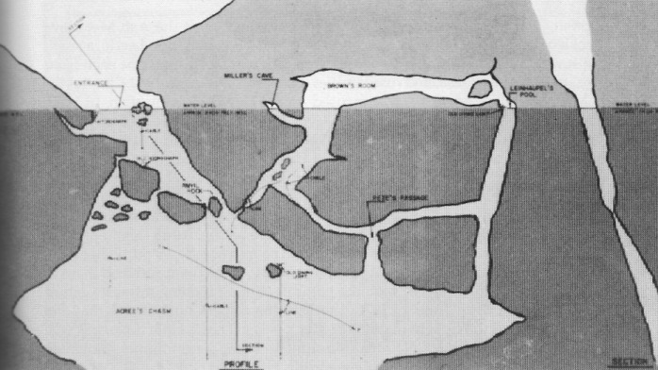
Cross section of Devils Hole; the light sections are above the water line. - Courtesy James E. Deacon—University of Nevada, Las Vegas; modified from an original map by Bill Acree.

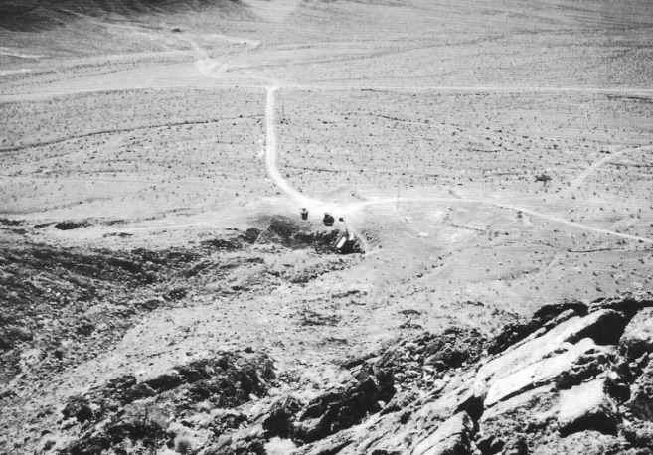
View of Devils Hole from the mountainside above, looking southwest. - Courtesy James E. Deacon—University of Nevada, Las Vegas

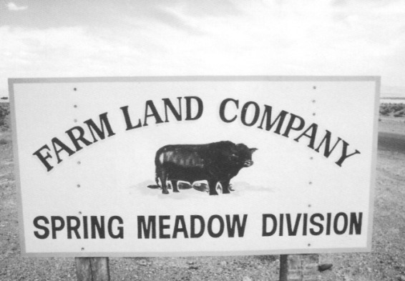
The Spring Meadows Ranch, a large cattle and hay-raising enterprise, was forced to cease operation because of its impact on the water level in Devils Hole. The Supreme Court ruled that the government had the right to maintain a minimal water level to protect the endangered pupfish. Courtesy James E. Deacon—University of Nevada, Las Vegas

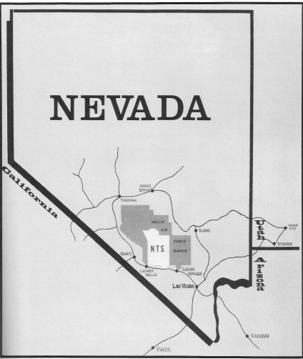
Map of Nevada, showing location of the Nevada Test Site (NTS). Lathrop Wells, located in the Amargosa Valley, was incorporated into the town of Amargosa Valley in the early 1980s. - Nye County Town History Project—U.S. Department of Energy Collection

Atomic Testing at the Nevada Test Site

The Nevada Test Site had been formally established and cordoned off by the time new pioneers such as Hank and Robert Records began farming in the early 1950s. Originally, the Atomic Energy Commission (predecessor of the U.S. Department of Energy, which presently operates the Nevada Test Site) had planned to build a community, perhaps similar to Los Alamos, New Mexico, in the Amargosa Valley. These plans were abandoned in favor of the Mercury site. The first nuclear tests in 1951 were easily visible and were witnessed by many Amargosa Valley residents. Although the testing did give rise to some anxiety, in general the community had an accepting view of the nuclear testing program. The Test Site has had some impact on the valley's development; a significant number of residents have been employed at the facility through the years.

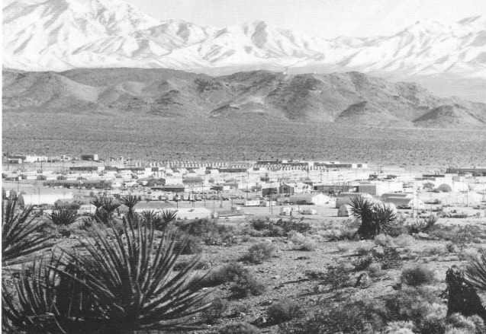
Mercury, the main base camp of the Nevada Test Site, is linked by Highway 95 to Las Vegas. The camp, which provides overnight accommodations for more than 950 people, includes a hospital, theater, bowling alley, cafeteria, and post office; there are no schools or family housing. The large plants in the foreground are yuccas. At one time, Atomic Energy officials considered locating the base camp, which became Mercury, in the Amargosa Valley. - Nye County Town History Project—U.S. Department of Energy Collection

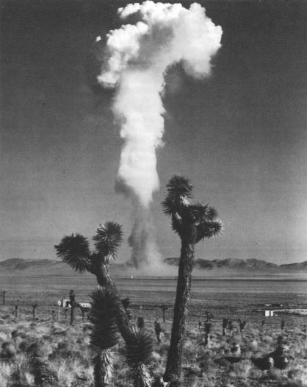
Amargosa Valley residents often saw mushroom clouds like this one after tests of atomic devices at nearby Yucca Flats (1950s). Central Nevada Historical Society—U.S. Department of Energy Collection

Adjusting to Life in the Amargosa Valley

Many of the newcomers who came to live in the valley during the 1960s were employed at the Test Site, in particular on the nuclear rocket engine program at Jackass Flats. The proximity of Jackass Flats allowed an easy commute, especially in comparison to the trip from Las Vegas. A number of individuals filed for land under the Desert Land Act, which was still in force. There was some private effort to develop small lots for those who did not want to go through the desert entry process. Residents at the west end of the valley at that time included the Dansbys, the Nickells, the Gareys, Hank and Robert Records, Jill Long, and two Selbach families. As during the 1950s, there were a number of men whose wives remained in a city, where life was more convenient and children were closer to schools. Residents in the Ash Meadows area of the valley included the Rookers, the Tubbs, and Pete Peterson. The two communities were separate socially.
Betty-Jo Boyd, then Mrs. Tracy W. Smith, and her husband moved to the valley in 1962, occupying the old home of Gordon and Billie Bettles. Betty-Jo remembered that it took time to become accustomed to living in such a remote desert area. Trips to "town," as Las Vegas was known to valley residents, were infrequent—every two weeks at first and then over the years falling off to once a month. People had to learn to buy ahead and plan for meals and other needs weeks in advance. Betty-Jo quickly learned that the desert is a demanding master. In the dry climate and sandy valley soil, plants and trees quickly die unless they are watered thoroughly and often. Betty-Jo emphasized, "Your trees need more attention. Your grass has to be watered often if you're to have any" (Boyd, 1987). Wooden buildings can dry out and deteriorate rapidly and must be constantly maintained to prevent leaking in one of the infrequent rains. It is a never-ending task to keep one jump ahead of the dust, which seems to blow into the house through invisible cracks in the walls. As Betty-Jo said, "You're a slave to everything you own out here. It's not a casual way of life. It's a very demanding way of life." She added quickly, "Life in the valley is full" (Boyd, 1987).
The hub of Amargosa Valley's social life in the 1960s was the post office, restaurant, and bar at Lathrop Wells. Most community members spent much of their leisure time socializing at the restaurant and bar. Additionally, the facility served as a kind of check station for those temporarily leaving the valley. When individuals went to Las Vegas, for instance, they always stopped at the bar and told the bartender (usually Harry Pippins) that they were leaving. Likewise, they reported in on their return home. Additionally, the Mecca Club, located at the junction of Mecca Road and the Lathrop Wells-Death Valley Junction highway, served as an informal social center, as did the Stateline Saloon after it opened in 1963.
By about 1964, most valley residents began to recognize the need for a formal community organization. Although the facilities at Lathrop Wells served a purpose as a community gathering place and information exchange, residents saw the need for a more formal organization, something with legally recognized status. Without it, community members had no way to communicate formally with county or state officials in Tonopah or Carson City. Valley residents organized the Amargosa Valley Improvement Association, known as AVIA, a nonprofit corporation. The Nye County district attorney, William P. Beko, assisted AVIA in drawing up its charter. Because there was no church, school, government building of any kind, and no meeting place beyond the three bars in the valley, the first order of business became construction of a community building. AVIA obtained a parcel of land and water rights, donated by Willard Johns, on the Farm Road just south of the Lathrop Wells-Death Valley Junction highway. Through volunteer labor provided by residents, AVIA constructed a community building, completed in about 1964.
Even during its construction, the AVIA building became a focus of community identity. It was the first tangible evidence that the Amargosa Valley was more than a number of isolated residences and that it was a viable and growing community of modern pioneers working together on the desert for the common good. Through AVIA, the town could formally communicate its needs to the Nye County commissioners. Regular representatives were sent to county commission meetings. Once completed, the AVIA building served as a place for all community meetings and as a center for dances and other social functions, including what became the valley's most important community event—the Amargosa Valley Barbecue that was held each Memorial Day weekend. AVIA also became involved in sponsoring recreational events such as softball tournaments and auto races. AVIA had been developed in response to a need, and that pattern was followed when development took place in the future.
As people continued to move into the valley during the early 1960s, families with small children became more numerous. At first, all children attended school in Beatty. Parents took them to Lathrop Wells, and a county school bus transported them from there to Beatty. In the middle 1960s the first attempts to solve the school problem resulted in adapting the AVIA building for use as a schoolhouse. Additionally, a small building was moved onto the ground behind the AVIA building for use as a schoolroom. Residents pointed out that at that time the Amargosa Valley was the only community in Nye County that furnished its own building for a school.
Beginning in the 1970s, long-term residents said that they began to notice an increase in interest in religion and church attendance. Since the 1970s four churches have been established; previously there had been none. Some residents see this as a natural development in the social life of the area. One resident noted,

It is very interesting to watch [the valley] go from a bar society to a church society. Here we've watched it all, [at first] you never saw anyone unless you went to the bar—but they [bars] had food, too, so you didn't necessarily have to drink. . . . Then, as ... [the community] evolved and as they [social needs] were filled by the AVIA, from the AVIA they went to churches (Boyd, 1987).

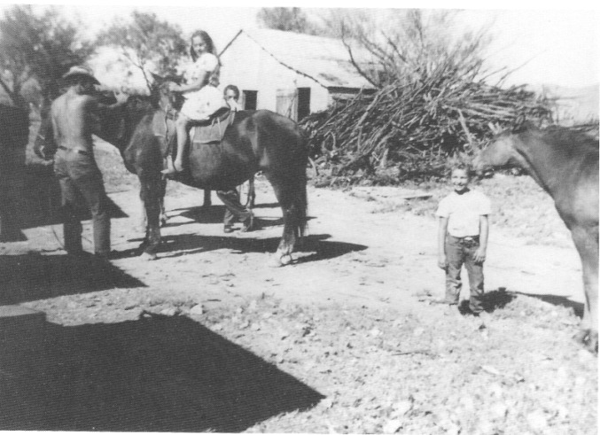
Nancy Tubb gets a kiss from her horse at the Tubb Ranch, located in Ash Meadows (circa 1950). Virginia Tubb is sitting on her horse. Nye County Town History Project—Goodson Collection

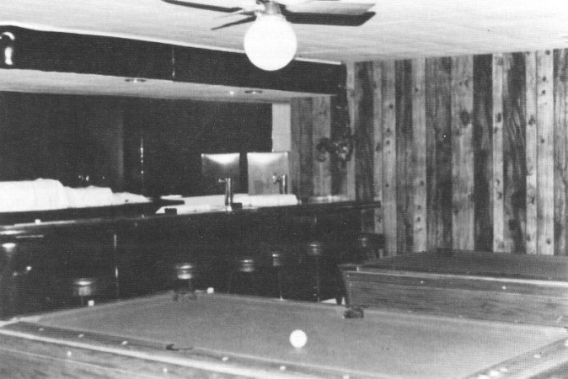
Interior of the Mecca Club, located at the junction of Mecca Road and Highway 373 (late 1970s). The club served as an informal social center. Nye County Town History Project—Fishel Collection

The Stateline—More Than a Saloon

In the pioneer West, especially in the mining camps, bars were traditional places for social gatherings. Though churches began to be important in the valley, they by no means replaced the bars as community social centers. The Stateline Saloon is a case in point. Fran York, owner of Fran's Star Ranch brothel, north of Beatty, bought the saloon in 1972 for her daughter Michelle Cohan and her son-in-law Joe. They ran it for eight years and then brought Doris Jackson in to manage it.
In 1973, Doris Jackson and her husband had moved to the Amargosa Valley after purchasing 60 acres in the northwest area. They grew fruit and nut trees, including almonds, figs, nectarines, apples, cherries, peaches, and apricots. They also raised grapes, including Zinfandels, California Red, Thompson Seedless, and Concords. They grew alfalfa by irrigating it with wheel lines, and they kept goats and chickens, selling goat's milk and eggs. Life on a farm in the Amargosa Valley was a marked contrast to the glamour Doris Jackson had experienced working at Caesars Palace, where she was employed prior to moving to the valley.
Jackson's experience in the Las Vegas casinos and her understanding of local residents formed a felicitous combination. In the first two months she managed the Stateline, she tripled the gross receipts. Dances, a happy hour, and such events as wet T-shirt contests all went over well. Her secret was that she treated people as she would want to be treated. Sufficiently satisfied with her managerial skills, she took an option on the Stateline and applied for a gaming license. In 1982 she was approved by the Nevada Gaming Commission and became the state's first female holder of a gaming license for an establishment wholly owned by a woman. After receiving the license, Jackson purchased the saloon and soon began expanding the facility (Jackson, 1987).
Under Jackson's ownership, the Stateline Saloon has become more than just a saloon. It is often a focus of community organization, second only to town government and the churches. Holidays—such as Valentine's Day, Easter, Fourth of July, Thanksgiving, and Christmas—are celebrated with dinner and a dance and singing at the Stateline. Birthday parties for senior citizens include live music, dinner, and prizes for winners of contests held during the event. On Easter Sunday, the saloon sponsors an Easter egg hunt for children in the valley; the tots have first crack at trying to find the less well-hidden eggs, and the older kids are challenged to find the eggs that are more cleverly concealed. The Stateline serves food as well as drink; everyone is welcome even just to talk. Moreover, the establishment has an additional extra special attraction—one of the most beautiful and picturesque desert views that a resident or traveler could ever hope to see—a stunning panorama of the south end of the Funeral Range, which when viewed through the saloon's front picture window looks as though John Ford, the cinematic chronicler of the pioneer West, had personally framed it.


Doris Jackson (center; 1989), who had worked in Caesars Palace in Las Vegas, owns and operates the successful Stateline Saloon in Amargosa Valley. She became the first woman to hold a gaming license in Nevada for an establishment wholly owned by a woman. - Nye County Town History Project—Jackson Collection


The Stateline Saloon is the focus of many community events - from weddings and holiday celebrations to birthday parties for senior citizens - Nye County Town History Project - Jackson Collection.

Amargosa Becomes an Unincorporated Town

The increased operations of the American Borate Company and Industrial Mineral Ventures in the 1970s brought more residents and a resultant increased demand for community services. The larger population and tax base led increasingly to the realization that the old AVIA organization was not effective enough in communicating community needs to county government. Consequently, residents began circulating petitions asking for designation of the Amargosa Valley as an unincorporated town. A large percentage of valley residents signed these petitions, and they were presented to the Nye County commissioners. Amargosa Valley was given formal designation as an unincorporated town, and its boundaries were drawn in 1982. The town covers most of the Amargosa Valley and is the second largest such community in the United States, encompassing 480 square miles. The only occupied section of the valley that was not included in the town is the area known as Crystal at the southeast end of the Amargosa Valley, where a number of families live and where a brothel is also located. Valley residents excluded the Crystal area because they felt that the one brothel located at Lathrop Wells was enough within the town borders; more might have harmed the community's reputation (Boyd, 1987; Jackson, 1987). (Once Lathrop Wells became part of the unincorporated town of Amargosa Valley, it assumed the name of the community of which it was now a part.)
Following the status change, members of the Amargosa Valley Town Advisory Council were summarily elected. The board holds monthly meetings in the valley and also meets on the first Tuesday of each month with the Nye County commissioners. Members are elected by popular vote; three serve for three years and two for two years. All issues are put to a vote at council meetings. And the system works. As Doris Jackson, an Advisory Council member, noted, "Even though sometimes things get voted down I personally would like, maybe later down the road, I see why it got voted down. It is like going back to the village square and having open meetings, which our democracy is built on" (Jackson, 1987).
Roads have been an important priority for the council, and work is progressing on a community park and cemetery. (In years past, many valley residents were buried in Beatty.) Demands for increased community facilities and services led to the recognition that the old AVIA building and adjoining facilities had been outgrown. "Being good true Americans," Doris Jackson jokingly said, "the first thing we [the Advisory Council] did was run in debt" (Jackson, 1987). An election was held to float bonds for the construction of a new community center, a clinic, and a library. Construction of all three was completed in 1984. Though the ABC mining operation closed and there were fewer people living in the valley, the community buildings, completed in the middle 1980s, serve as the focal point of community pride and identity.

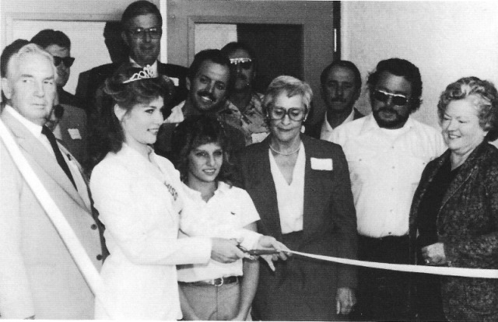
Ribbon-cutting ceremonies at the dedication of the Amargosa Community Building, November 2,1984. Right to left (front row): former Nye County Commissioner Jacque Ruud, Nye County Commissioner Bob Revert, and Amargosa Valley resident Betty-Jo Boyd; State Senator Ken Redelsperger is in the second row (with mustache, behind and to the left of Betty-Jo Boyd). Other people not identified. Nye County Town History Project—Records Collection

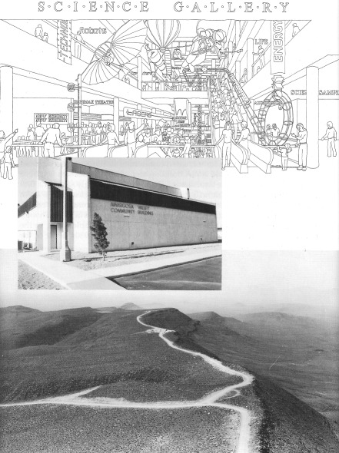
Artist drawing of proposed science museum, Amargosa, Valley. Courtesy E. Verner Johnson and Associates, Inc. The Amargosa Community Building (1990). Courtesy Bill Copeland Yucca Mountain, the proposed site for a high-level nuclear waste repository, is located about 100 miles northwest of Las Vegas on the northeastern edge of the Amargosa Valley. The Amargosa Valley is visible in the upper right portion of the photo. Nye County Town History Project—U.S. Department of Energy Collection

CHAPTER SEVEN
The Future

Amargosa Valley residents are unanimous in their love for their valley and the life-style they lead. And despite economic setbacks in the 1970s and 1980s (cessation of farming at Ash Meadows and fluctuations in mining and employment at the Nevada Test Site), valley residents look to the future with optimism. They know the valley's resources, the quality of life the valley offers, and the unparalleled opportunities to experience the beauty and enjoy the solitude and freedom of the desert. They are convinced the Amargosa Valley will continue to be a place in which residents can earn a good living or retire. Growth is encouraged by valley residents as long as it is not excessive.
Valley residents are confident that they will prevail in controversies over wild horses and development of the valley's water resources. They are pleased that ABC has reopened (though on a limited basis) and enthusiastically support Nye County's effort to locate a modern science museum near the intersection of U.S. Highway 95 and State Highway 373. Residents believe the development and promotion of the Ash Meadows National Wildlife Refuge, the proposed science museum, and the valley's proximity to Death Valley will bring more tourists to the area.
Many people believe that the community will continue to play an important role in the research and development in both defense and nondefense industries. They are proud of their pioneering role in the development of nuclear weapons and in research on such projects as the nuclear rocket engine.
Residents of the Amargosa Valley may once again be front-row observers, and possibly participants, in a major federal nuclear program: the disposal of the nation's spent fuel and high-level radioactive waste in a manner that protects the health and safety of the public. In 1987 the U.S. Congress selected Yucca Mountain, located in the northern part of the valley, as the preferred site for the nation's first underground, high-level nuclear waste repository. A repository may be constructed inside Yucca Mountain if the site is proven to be geotectonically suitable. Although the suitability of the site may not be known until the beginning of the next century, many residents view the location of a nuclear waste repository at Yucca Mountain as a challenge because the safe disposal of nuclear waste would benefit humanity and the environment. They believe that negative impacts of a repository must be avoided and positive effects maximized. They view with dismay the words and efforts of those who would abandon nuclear technology because of its difficulties. The new pioneers in the Amargosa Valley believe that nuclear technology and the desert, with its freedom and incredible beauty, can coexist productively and harmoniously.

References

Belden, L. Burr. Goodbye Death Valley. Bishop, CA: Chalfant Press, Inc. 1956.

Boyd, Betty-Jo Smith. An Interview with Betty-Jo Smith Boyd. Nye County Town History Project, Tonopah, NV. 1987.

Brockman, Frank and Edith. An Interview with Frank and Edith Brockman. Nye County Town History Project, Tonopah, NV. 1987.

Brooks, Thomas W. Edited, with introductory notes by Anthony L. Lehman. By Buckboard to Beatty: The California-Nevada Desert in 1886. Los Angeles: Dawson's Book Shop. 1970.

Carlson, Helen S. Nevada Place Names: A Geographical Dictionary. Reno: University of Nevada Press. 1974.

Cook, Sid F., and Cynthia D. Williams. The Status and Future of Ash Meadows, Nye County, Nevada. Carson City: Office of the Attorney General, State of Nevada. 1982.

Gower, Harry P. 50 Years in Death Valley—Memoirs of a Borax Man. Introduction by James M. Gerstley. Published by the Death Valley '49ers. Publication No. 9. San Bernardino, CA: Inland Printing and Engraving Company. 1969.

Hansen, Ernest H. "Forrest." An Interview with Ernest H. "Forrest" Hansen. Nye County Town History Project, Tonopah, NV. 1987.

Jackson, Doris M. An Interview with Doris M. Jackson. Nye County Town History Project, Tonopah, NV. 1987.. Personal communication. 1989.

Johnson, Leroy and Jean. Escape from Death Valley. Reno: University of Nevada Press. 1987.

Lingenfelter, Richard E. Death Valley and the Amargosa: A Land of Illusion. Berkeley: University of California Press. 1986.

Lisle, Ralph F. Personal communication. 1989.

Lowe, Celesta Lisle. An Interview with Celesta Lisle Lowe. Nye County Town History Project, Tonopah, NV. 1988.

Lowe, Deke. An Interview with Deke Lowe. Nye County Town History Project, Tonopah, NV. 1988.

Myrick, David F. Railroads of Nevada and Eastern California. Berkeley: Howell-North Books. 2 vols. 1962, 1963.

Records, Henry H. "Hank." An Interview with Henry H. "Hank" Records. Nye County Town History Project, Tonopah, NV. 1987.

Revert, Robert A. An Interview with Robert A. Revert. Nye County Town History Project, Tonopah, NV. 1988.

Spears, John R. Illustrated Sketches of Death Valley and Other Borax Deserts of the Pacific Coast. Chicago and New York: Rand, McNally & Co., 1892. Reissued by Sagebrush Press, Morongo Valley, CA. 1977.

The Statutes at Large of the United States of America from May, 1919 to March,1921. Vol. XLI. Part 1. Washington, DC: U.S. Government Printing Office. 1921.

Steward, Julian H. Basin-Plateau Aboriginal Sociopolitical Groups. Washington, DC: Smithsonian Institution, Bureau of American Ethnology, Bulletin 120. 1938. Reprinted by University of Utah Press, Salt Lake City. 1970.

Toles, Herbert L. An Interview with Herbert L. Toles. Nye County Town History Project, Tonopah, NV. 1987.

Trexler, Dennis T., and Wilton N. Melhorn. "Singing and Booming Sand Dunes of California and Nevada." California Geology. July. Pp. 147-152. 1986.

Warren, Elizabeth von Till. "Armijo's Trace Revisited: A New Interpretation of the Impact of the Antonio Armijo Route of 1829-30 on the Development of the Old Spanish Trail." Unpublished M.A. thesis. Las Vegas: University of Nevada. 1974.

"History of the Amargosa-Mojave Planning Units" in Claude N. Warren, Martha Knack, and Elizabeth von Till Warren. A Cultural Resource Overview for the Amargosa-Mojave Basin Planning Units, pp. 195-257. Las Vegas: University of Nevada. 1980.

Zanjani, Sally. Jack Longstreet: Last of the Desert Frontiersmen. Athens, OH: Swallow/Ohio University Press. 1988.

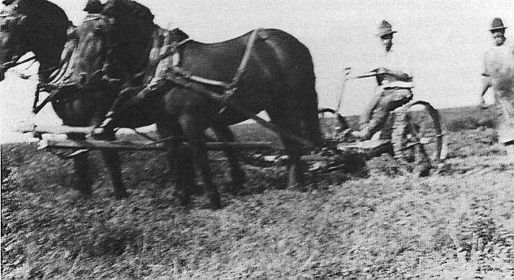
Horse-drawn mowing machine on the T&T Ranch (circa 1920). - Nye County Town History Project—Fishel Collection

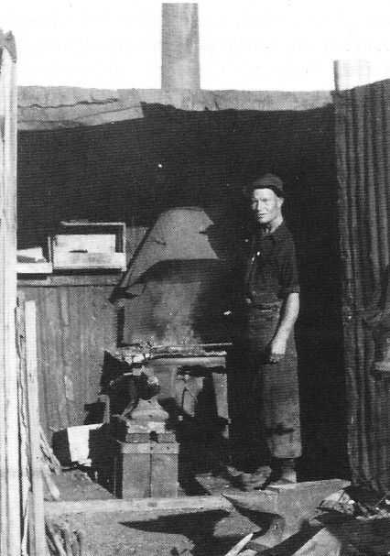
Fred Davies in his blacksmith shop in Ash Meadows (1930s). - Nye County Town History Project—Reidhead Collection

About the Author

Robert D. McCracken, a descendant of three generations of hardrock miners, was born in the high country of Colorado, where he lived until he was eight. His love for Nevada and its people began in the 1950s when he and his brother helped his father operate mines at several sites in Nye County, including Reveille Valley and Silver Bow. During his college years, McCracken worked in Nye County on construction jobs. He earned his Ph.D. in cultural anthropology at the University of Colorado and has taught at Colorado Women's College, California State University at Long Beach, and UCLA. He is the author of numerous scientific reports and articles and was cited in Time for his work on human evolution. In 1981 he and his daughter, Bambi, returned to Tonopah, where his father had retired. He began the Nye County Town History Project in 1987.

books from \ye County Press
by Robert D. McCracken

A History of Amargosa Valley, Nevada (cloth) ISBN: 1-878138-56-1

The Modern Pioneers of the Amargosa Valley (paper) ISBN: 1-878138-58-8

A History of Beatty, Nevada (cloth) ISBN: 1-878138-54-5

Beatty: Frontier Oasis (paper) ISBN: 1-878138-55-3

A History of Pahrump, Nevada (cloth) ISBN: 1-878138-51-0

Pahrump: A Valley Waiting to Become a City (paper) ISBN: 1-878138-53-7

A History of Tonopah, Nevada (cloth) ISBN: 1-878138-52-9

Tonopah: The Greatest, the Richest, and the Best Mining Town in the World (paper)
ISBN: 1-878138-50-2

Nye County Press
P.O. Box 3070
Tonopah, NV 89049

